Tuya Smart Fingerprint Lock Operation Instructions V1.0

APP installation
1. Download and install the "Tuya Smart" APP from the application market.
2. After installation, follow the prompts to register and log in.

Distribution network connection lock
1. Start the network distribution process: click to add a device
2. Long press the fingerprint for 10S on the lock end (if fingerprints have been registered in the lock, the administrator fingerprint authentication is required) or long press the reset button (some locks may not have this button) until the red light is on, then release the button. The machine automatically enters the network distribution mode;
3. When the mobile phone opens the APP, the device will automatically pop up, the device name is "smart-lock", just add the device.
" 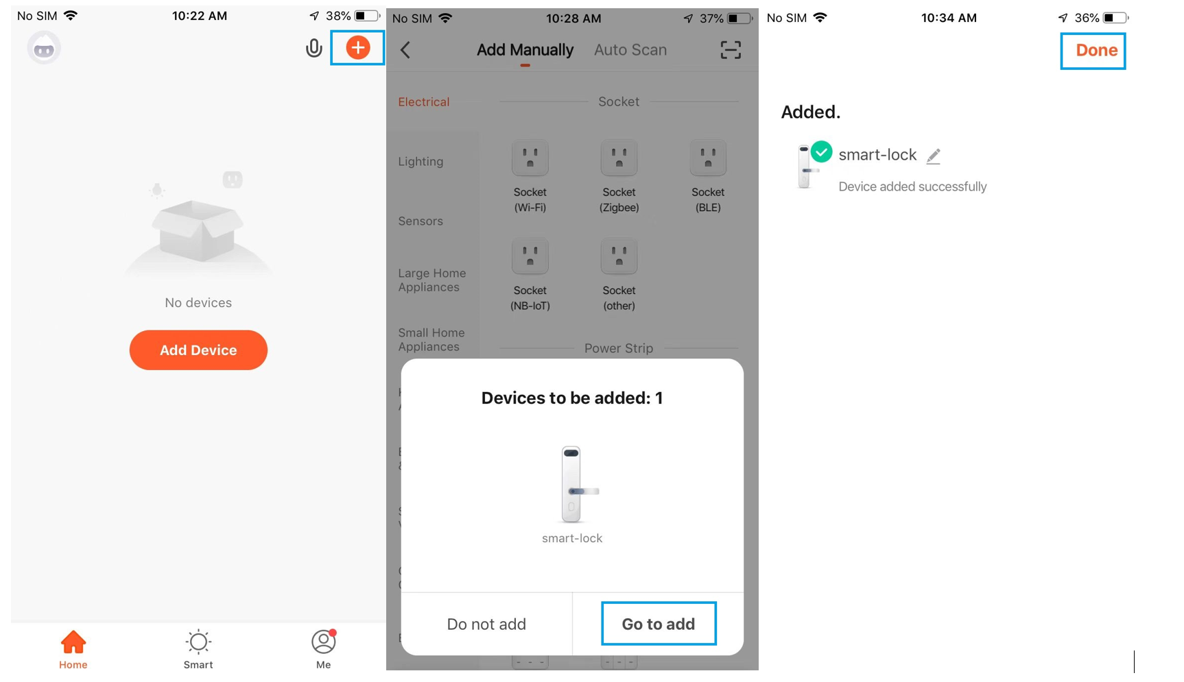,
4. If the device does not automatically pop up after opening the APP on the phone, please set and add the device in this way
Open the APP, click to add a device, select "Security &Video Surveillance " → "Smart Lock" → " Lock (BLE)" → click "Enable Bluetooth network distribution", search for the device and add the device.
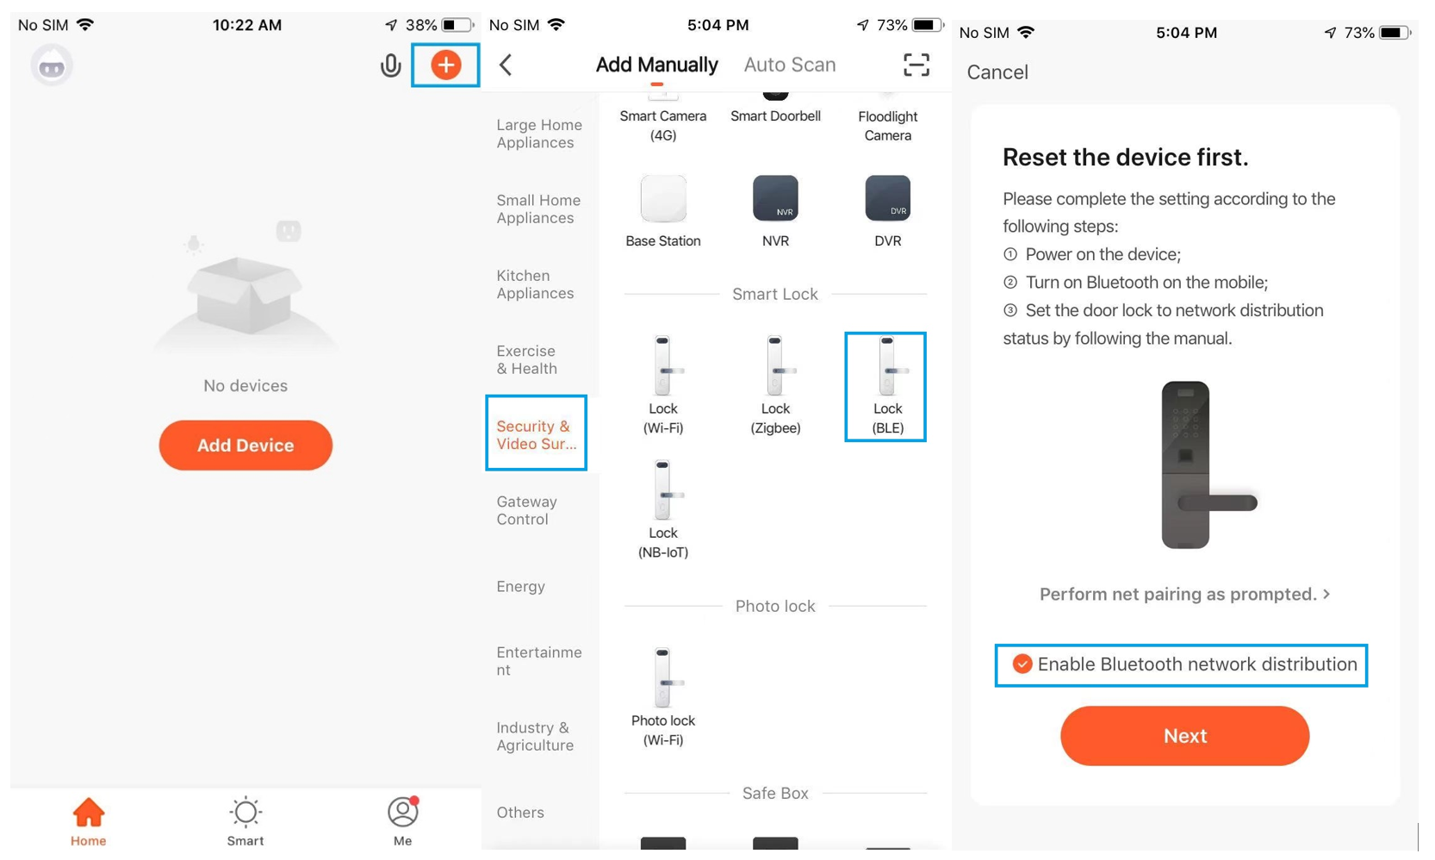
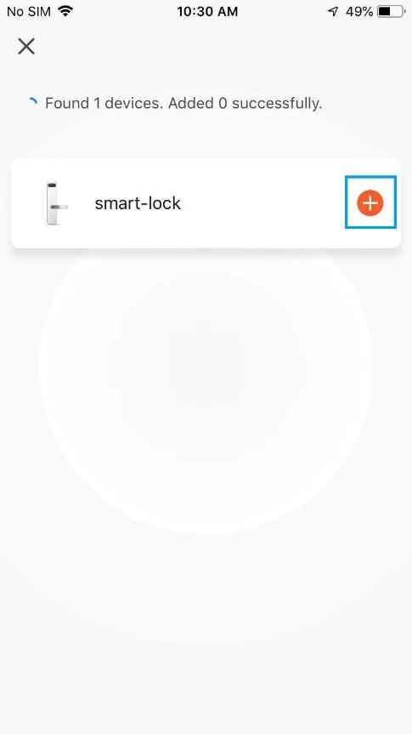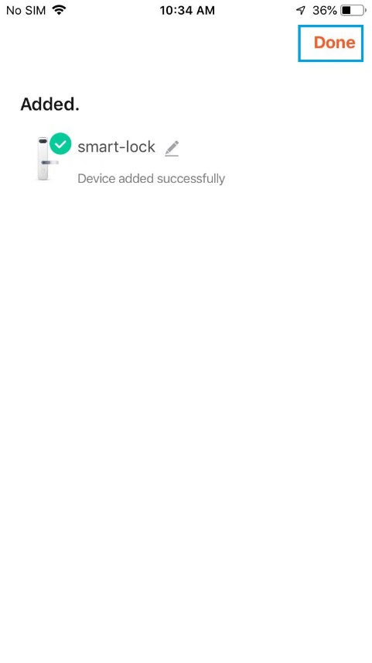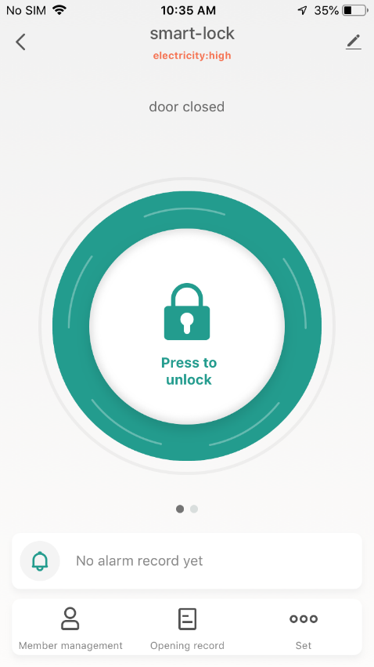

Member management
- Member management
Click "Member Management" on the unlock interface and select "+" in the upper right corner of the interface
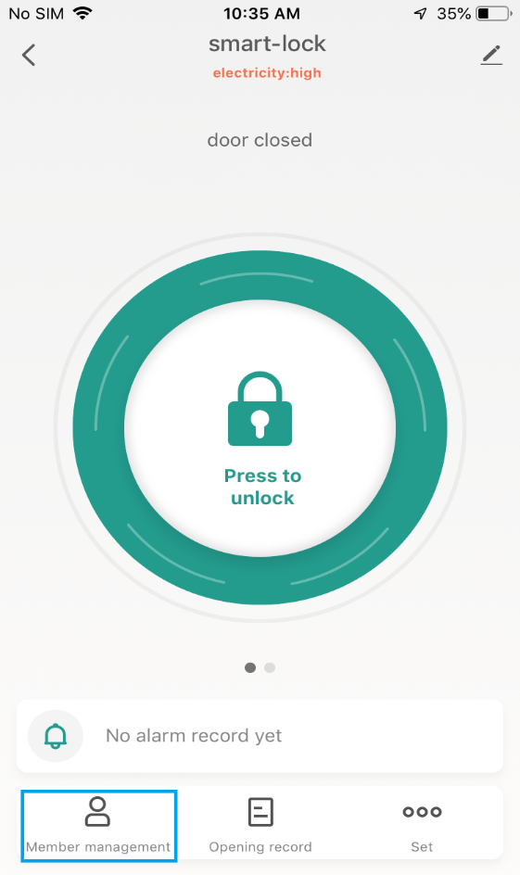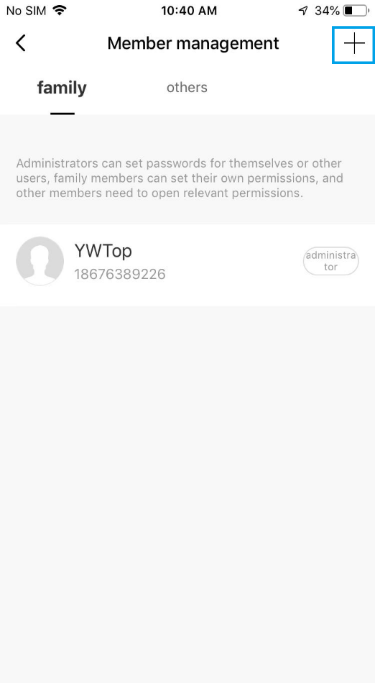l222
- Family
The first registered family member is the administrator, click "Family Member" → "Add it now" → "Home name" → "Add Member", if the WeChat method is selected, the system will automatically go to the WeChat interface and send the invitation code to the family member .
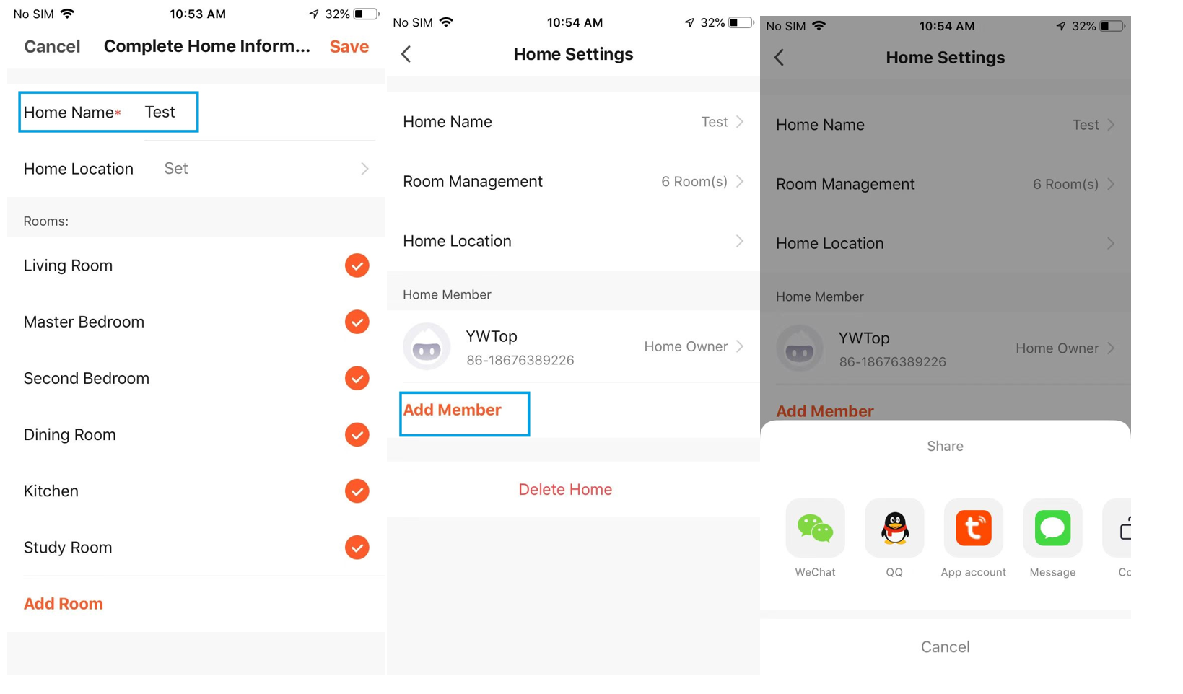
After the family members receive the information to add members, download and register the Tuya APP, go to "Me"→"Home Management”→Find the family where they are located, and accept the invitation to add them successfully.
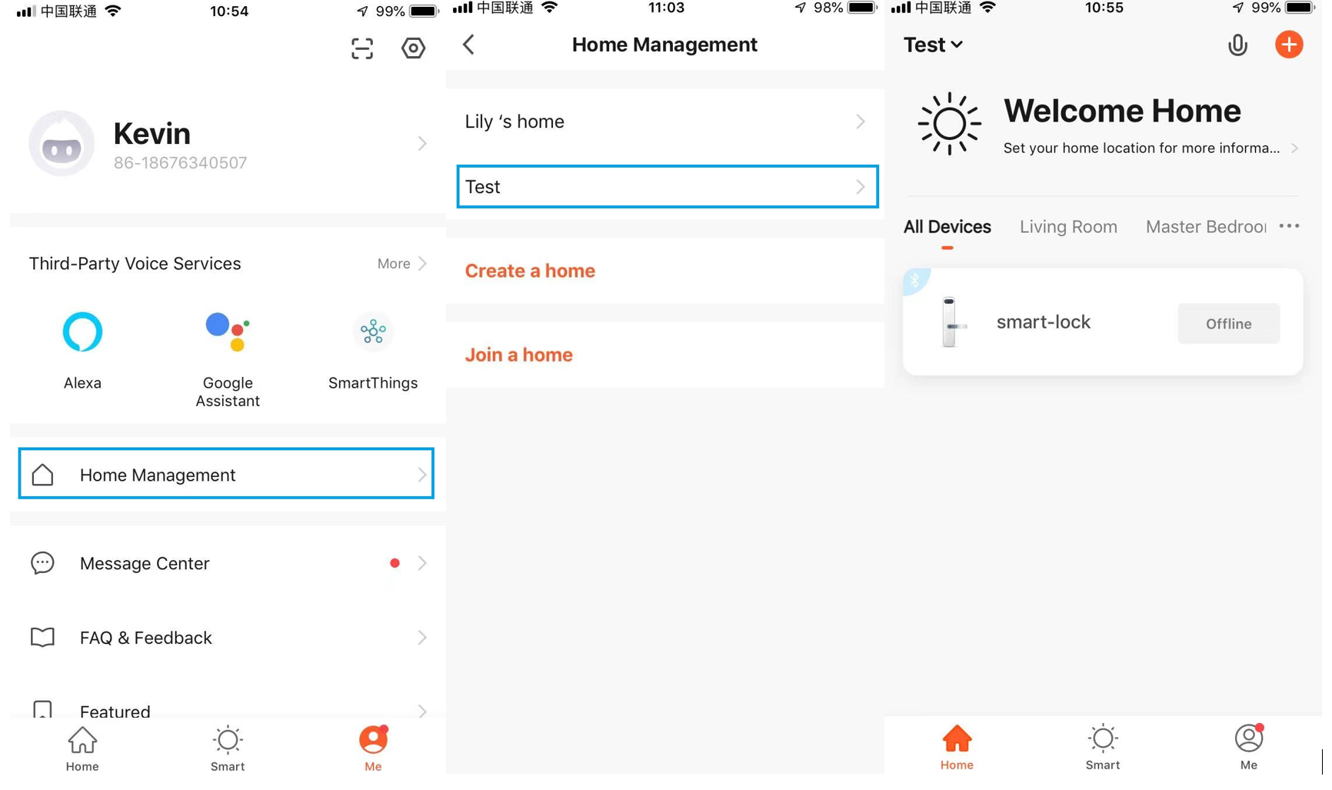

Delete Home members: "Me"→"Home Management"→"Home Settings"→Long press the Home member you want to delete, and select "Remove Member".
- Others
Select "Member Management" → "Others " → "+" in the upper right corner to add other members. The time limit and effective date must be set.
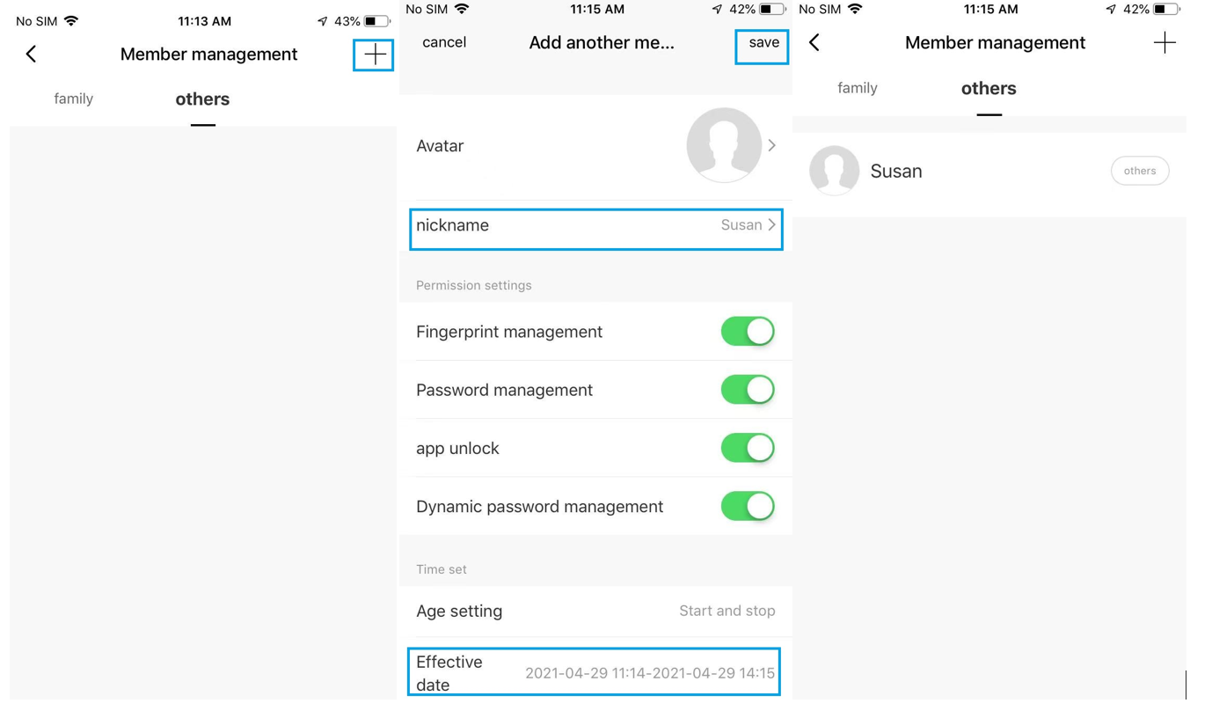
Deleting others is the same as deleting Home members.

Unlock method
1.The first method: you can directly add fingerprints, passwords, cards, and dynamic passwords in the specific user interface under "Member Management".
2. The second method: add it in the setting interface.
3. The difference between the two methods: the first is to add an unlocking method for a user (such as fingerprint, password, card); the second is to use this method under specific unlocking methods (such as fingerprint, password, and card) The mode corresponds to a certain user.
4. The second method is introduced below
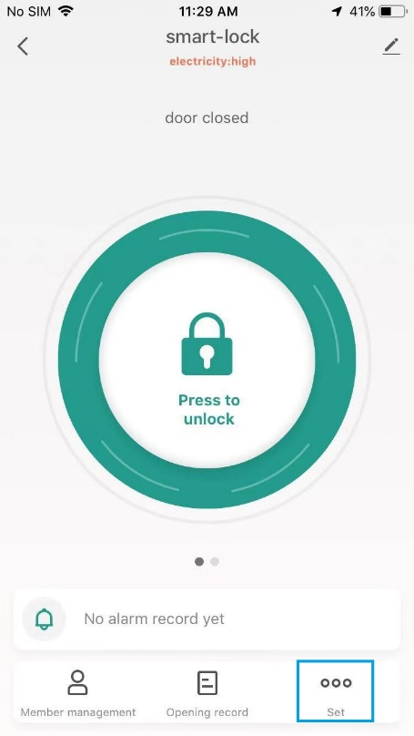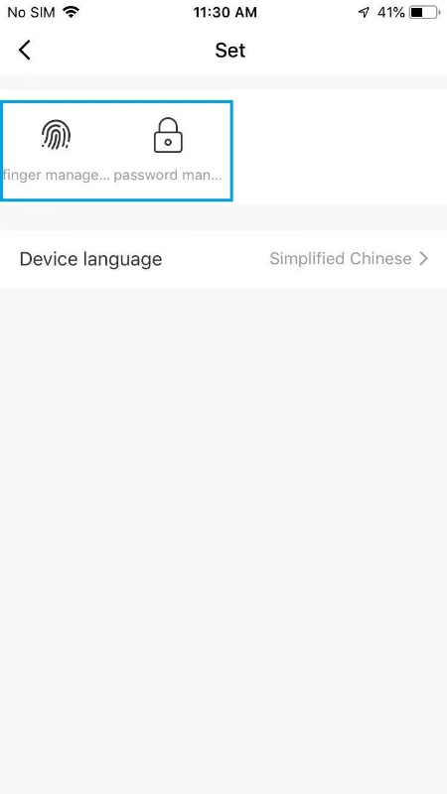
- Finger management:
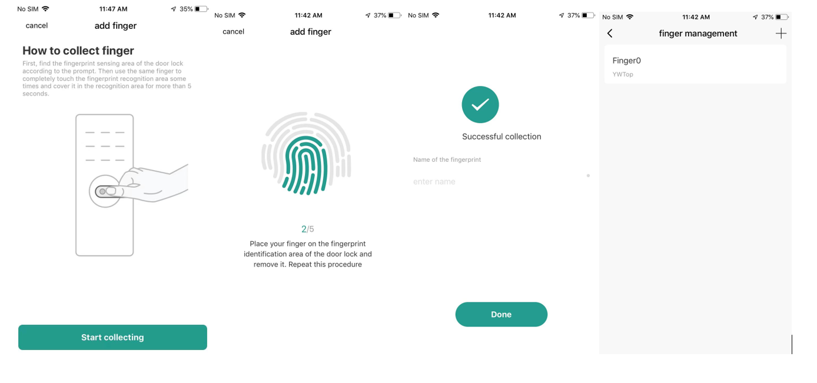
Add fingerprint: After selecting a user, follow the prompts to enter it.
Note: Only after the administrator's fingerprints are entered, can other users' fingerprints be entered, and the administrator's fingerprints cannot be deleted. There is no such requirement for other unlocking methods. See "Graffiti Operation FAQ"

- Password management
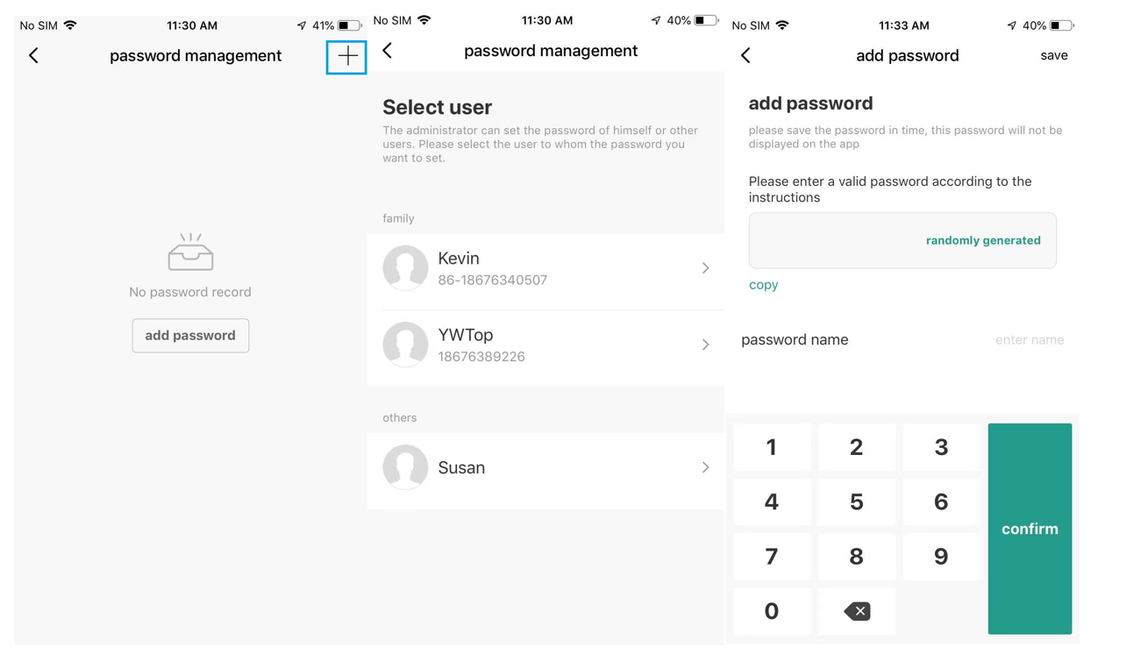
Add password: The password can be randomly generated or entered by the user. For specific digit requirements, see "Tuya Operation FAQ"

Dynamic code
1. This function only supports lock bodies with touch codes, and does not support virtual codes.
2. The dynamic code operation process is as follows:
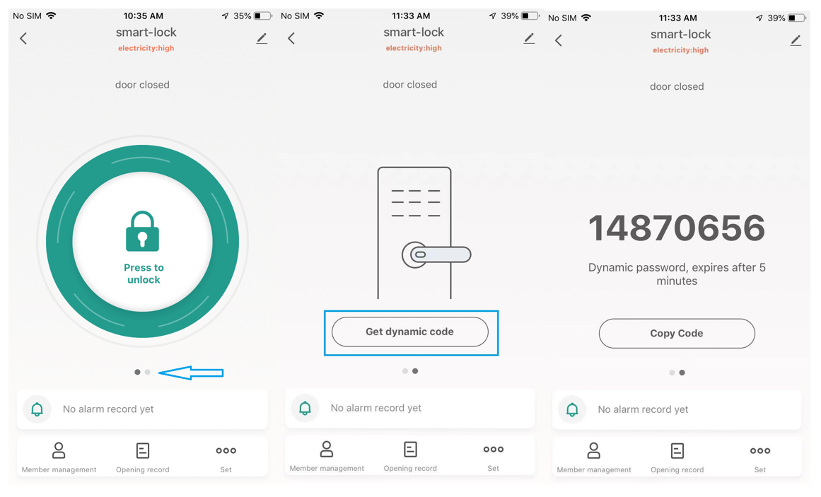
On the unlock interface, swipe your finger left to enter the next interface and click "Get dynamic code" to generate a dynamic code;
- Enter the code at the lock end to unlock

Restore factory settings and unbind
1.Unbind the lock terminal: The premise is that the lock and Tuya APP must be disconnected, press and hold the reset button until the red light is on, then release the button to enter the automatic network configuration, and the network configuration will restore the factory settings. Or long press the fingerprint for more than 10 seconds, after the red light turns on, lift your finger, enter the administrator's fingerprint, and restore the factory settings;
2. Unbinding on APP:
a) The lock is connected to the Tuya APP
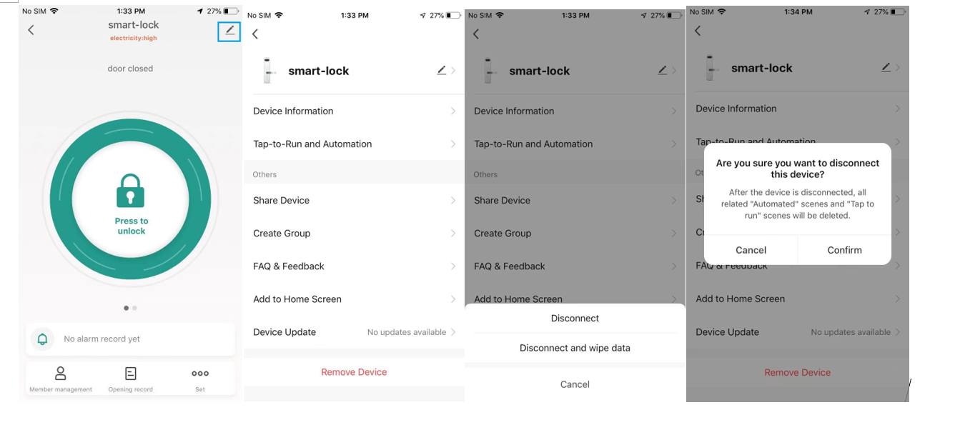
Operate according to the above figure, click "Disconnect and wipe data", the device will be completely restored to factory settings
b) If the lock and Tuya APP are not connected: directly unbind a lock on the APP side, after the lock is connected to Tuya APP next time, the existing users and unlocking methods on the lock side will still exist and will be updated To the APP.

Tuya operation FAQ:
1. Unlocking method: fingerprint unlocking, password unlocking, card unlocking;
2. A user can have multiple unlocking methods, and in this unlocking mode, there can be multiple unlocking realizations. For example, Zhang San can unlock fingerprints, passwords, and cards, and there are 10 fingerprints, 30 sets of passwords, and 20 cards;
3. After the lock body is restored to the factory settings, it will automatically enter the network distribution mode; after entering the network distribution mode, it will also automatically restore the factory settings;
4. Does not support virtual password function;
5. The first fingerprint entered must be an administrator. But passwords and cards do not have this restriction.
6. The number of touch buttons is related to the digits of the user password: there are 10 (0-9) for the machine touch password number keys, the user password digits are 6; the touch password number keys have 8 or 9, then the user password digits The number is 7 digits; there are only 4 to 7 digits for the touch password, and the user password has 8 digits; as follows:
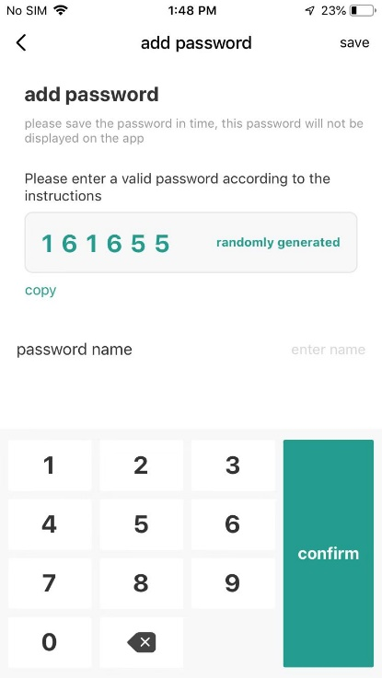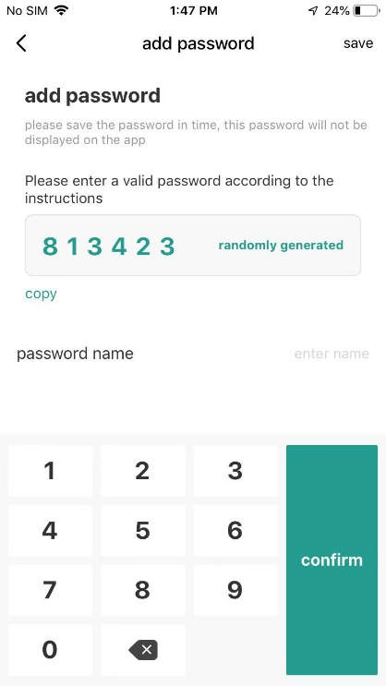
7. The dynamic code generated by the APP has 8-11 digits, and the user can unlock it by directly inputting it at the lock end. as follows:
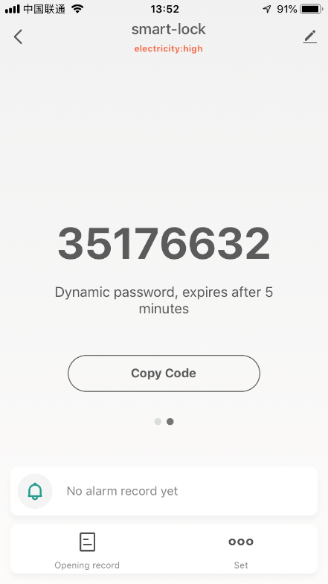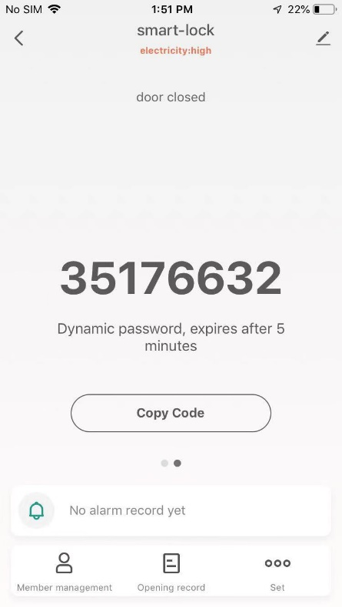
8. When the lock body is connected to the APP for the first time, the network configuration operation must be performed; the network configuration operation will restore the factory settings; so if you want to restore the factory settings, you can enter the distribution network;
9. There are two ways to operate the lock body to enter the network distribution process: long press the fingerprint head to enter or long press the reset button to enter the network distribution mode; some locks do not have a reset button, and you can only enter the distribution network by long pressing the fingerprint operation. If there is a fingerprint in the lock, the administrator's fingerprint needs to be verified, and it can only be operated when the APP and the Bluetooth of the lock are not connected.

