4G +2G Built-in Antenna GPS Tracker

Product Manual

Product model: J16-SA
Version No.: V1.0
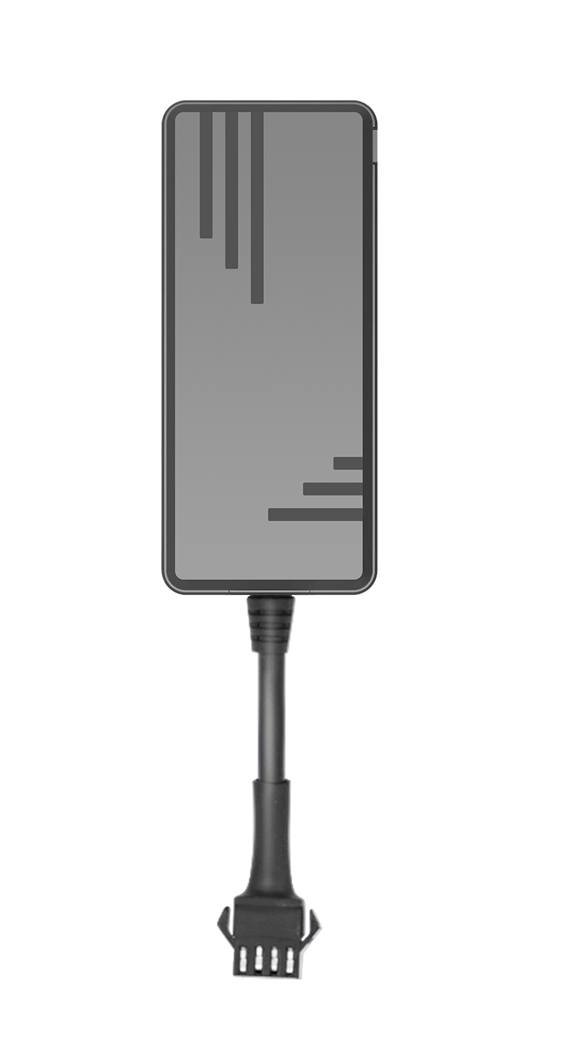
Legal statement:
First of all, thank you for using this product. If you have agreed to the following terms, you will receive our support and services. When you have doubts about this, please call for consultation. If you cannot accept the following terms, please stop using this manual.
The ownership of this manual belongs to the distributor. Any rights that not expressly granted in this manual are reserved. Without the prior written permission of the distributor, no company or individual shall copy, transmit, distribute, use or disclose the product information in the manual and any pictures, forms, data and other information contained in the manual.
Without the distributor's prior written consent, reading this document does not imply to grant the reader any right to use any mark appearing in this document.

The storage and use of this product shall comply with the requirements of the product manual, relevant contracts or relevant laws and regulations.

The distributor reserves the right to modify and improve the products described in this manual without prior notice; At the same time, we reserve the right to revise or withdraw this manual at any time. If there is any ambiguity in the user manual, please consult the agent and seller in time.

Special statement:
This product is only used for anti-theft of vehicles, and it is prohibited to use it for illegal purposes, otherwise all legal liabilities arising therefrom shall be borne by the user.

Product Features
- 4G built-in antenna, high integration design
- 9 - 90V wide voltage, real-time location tracking, track playback
- Simultaneously supports the Tianqin protocol, GT06 protocol, and 808 protocol, enabling command-switching transmission
- Vibration alarm, Over-speed alarm, Entry and exit electronic fence alarm
- Vehicle engine start and turning off detection
- Easy installation, no need to press the power button, it will work immediately after power on
- Built-in backup battery, prompt alarm will be triggered when being illegal removal
- The device can be connected to a relay to realize remote oil and power cutoff function
- GPS+BeiDou+LBS triple positioning
- Supports anti-blocking and anti-interference features
- Supports remote OTA

- Product Appearance and Accessories
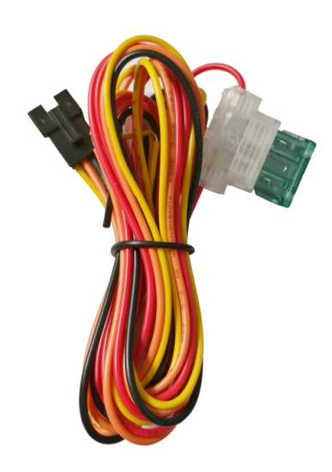
Device power cable

3. Production Wiring Diagram 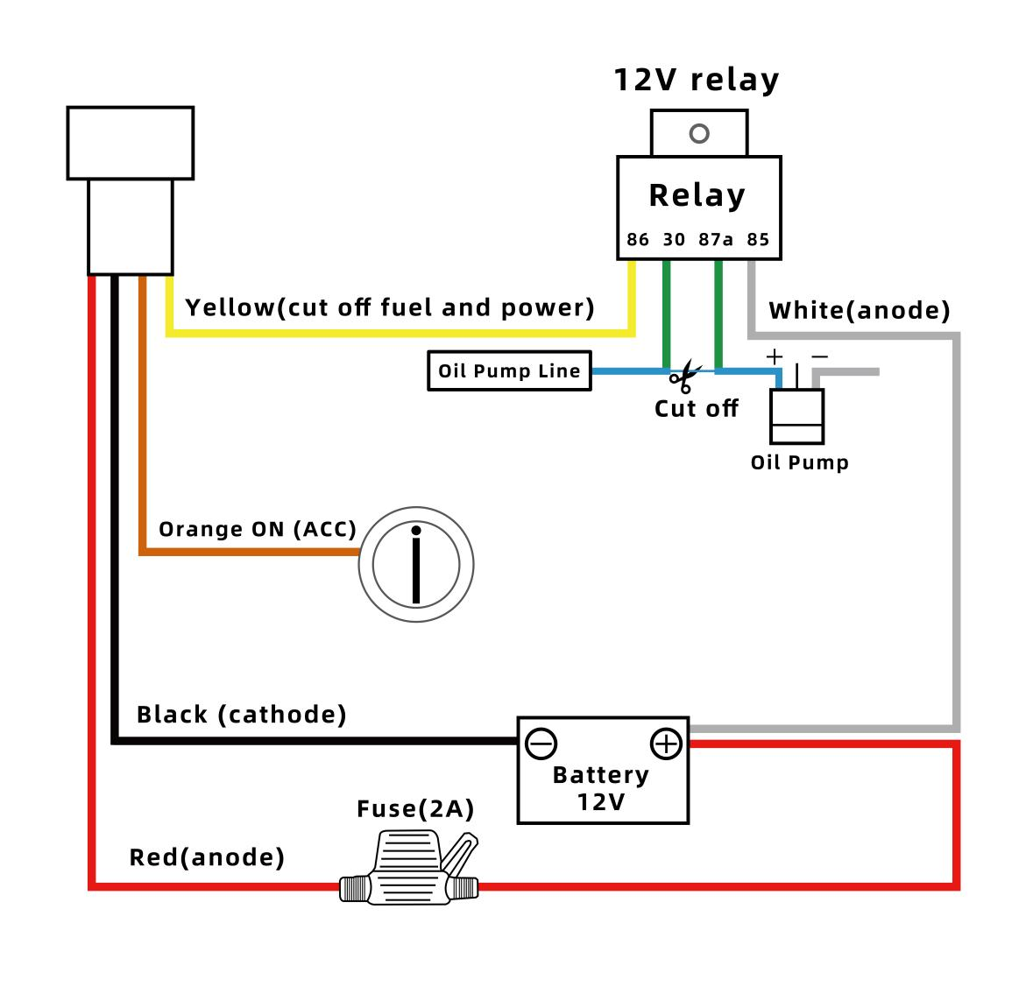
4. Product Parameters

Specification | Parameters
Size | 80.1*35*17.3mm
Weight | 49.1g（battery included）
Built-in battery | 150mAH（3.7V）
Operating temperature | -20°C to +60°C
Storage temperature | -20°C to +70°C
Sensor | Precision Vibration Sensor
Frequency band | LTE-FDD:B1/B2/B3/B4/B5/B7/B8/B28/B66 GSM/GPRS/EDGE 850/900/1800/1900MHZ
Communication module brand/chip model | SIMCOM-A7670SA
Positioning module brand/chip model | AT6558R
Root Mean Squares Error ( RMSE) | S degrees
Maximum output power | EGSM900:33dBm±2dB/5dBm±5dB  DCS1800:30dBm±2dB/0dBm±5dB  EGSM900 (8-PSK)：27dBm±3dB/5dBm±5dB  DCS1800 (8-PSK)：26dBm±3dB/0dBm±5dB  LTE-FDD B1/B2/B3/B4/B5/B7/B8/B28/B66：23dBm±2dB/<-39dBm
Dynamic output range | -15~-108dbm
Receive sensitivity | -107dbm
Maximum frequency deviation | ±0.1ppm
Sensitivity | Cold start：-145 dbm  Hot Start：-156 dbm  warm start：-145 dbm  navigation：-160 dbm  track：-162 dbm
First position time | Cold start: 32 seconds on average
GSM antenna | built-in
GPS antenna | built-in
LED indicator | power, indicating status
Transfer Protocol | TCP
Power detection | Upload alarm information when the main power is disconnected
Data upload | Update GPS data in real time and support customization
Geo fence | TBD
Driving behavior detection | When the vehicle speed exceeds the set speed, the device will upload the over-speed alarm
GPS data | Real-time location updates
Vibration alarm | Vehicle vibration report in armed state

- Basic Product Function

Use |  | Function | Description
GPS tracking and locating | 4G network |  | Supporting 4G network, 1 second efficient transmission, faster and more accurate
GPS tracking and locating | Timing tracking |  | Reporting positioning information such as latitude and longitude according to the set interval
GPS tracking and locating | Over-speed alarm |  | The tracker will send an alarm to your mobile phone when driving speed is too fast
GPS tracking and locating | Vibration alarm |  | Built-in vibration sensor, when the vehicle vibrate continuously, the device will immediately send an alarm information
GPS tracking and locating | Geo fence |  | when the driving range of the car exceeds the specified area, an alarm message will be sent to the platform
GPS tracking and locating | Historical track |  | The platform can play back of history driving route, including speed, direction and stay time, etc.
GPS tracking and locating | Displacement alarm |  | When the vehicle is being illegal operation or being theft, users can remotely cut off the oil and electricity through the computer or mobile APP
GPS tracking and locating | Fleet management |  | One account can monitor multiple devices, or one device can be monitored by multiple accounts

Analysis and Troubleshoot of Common Problems
If the yellow light and blue light of this product are always on and do not flash, it means that the device is normal online positioning. In case of flashing, please follow the following steps to analyze and troubleshoot.
Trouble | Analysis | Solution
Blue light flashing slowly | Whether to use the device in areas with poor GPS signals, such as near high-rise buildings or underground parking lots | Drive the vehicle to the position with good signal and reinstall the device
Blue light flashing slowly | Whether the front windshield of the vehicle is pasted with metal heat insulation film, which affects the signal reception | If there is a film, use the device in another vehicle to test whether the blue light is always on. If there is no problem in testing on other vehicles without film, it is caused by the film of the vehicle
Blue light flashing slowly | Whether there are shields or signal jammers on or around the vehicle | If there is a shield or signal jammer, remove the shield or signal jammer and try to reinstall the device
Blue light flashing quickly | Chip failure | Return to factory for maintenance
Yellow light flashing quickly | Whether the SIM card is installed properly | Make sure the SIM card is installed correctly
Yellow light flashing quickly | Whether the metal surface of SIM card has dirt or poor connect | Wipe the metal chip surface with a clean cloth or repeatedly insert and remove the card several times
Yellow light flashing slowly | Whether the vehicle is in a place without network, such as an underground parking lot | Please drive the vehicle to a place with good network signal and try to reinstall the device
Yellow light flashing slowly | Whether the server platform is normal | Ask background management whether the platform server is working normally
Yellow light flashing slowly | Whether the SIM card status is normal | Check whether the card status is normal through the SIM card query platform
Yellow light flashing slowly | Whether there are shields or signal jammers on or around the vehicle | If there is a shield or signal jammer, remove the shield or signal jammer and try to reinstall the device

Product Precautions
- Please pay attention to waterproof of electronic products.
- Please insert the SIM card before installation to ensure that the SIM card has no password, otherwise the device will not work properly.
- The USB port on the terminal device is dedicated for factory testing, and it is not a device charging port. Do not use it for charging or other purposes.
- There must be no substance absorbing electromagnetic wave (such as metal, explosion-proof insulating film) above the installation position.
- Do not touch the device with liquid or operate it with wet hands.
- Do not put the device into fire.
- The device may not work when the temperature is lower than - 20 ℃ or higher than+60 ℃.
- When the vehicle is in the underground parking lot, tunnel or garage, the positioning signal will be affected. And there may be blind areas of communication network signals, which may cause the device to be unable to monitor; When the vehicle drives out of the above area, the device will automatically resume normal operation.
- In case of abnormal conditions, please do not repair by yourself. The manufacturer shall not be liable for any damage caused by connecting non original accessories or unplugging the connections between components.
- This product is an auxiliary product for safe driving, and any loss caused by failure or information loss has nothing to do with our company.
- Because of the complex electromagnetic environment in the vehicle, this product may have electromagnetic interference with the electrical equipment in some vehicles.
- Do not install or operate this product when the vehicle is running.
- Do not connect the device to uninterruptible power supply without authorization, or it may cause vehicle or product failure. Please consult with a professional about installation.
- Do not shock or throw the product violently, so as to avoid damaging the product, which may lead to malfunction or failure to use.
- The temperature range for normal use of this product is - 20 ℃ to 65 ℃. Exceeding this temperature range may lead to product failure, on fire or explosion.

