Central Loose Tube Aerial Self Supported, G.652D, FRP, MDPE
Cable Design

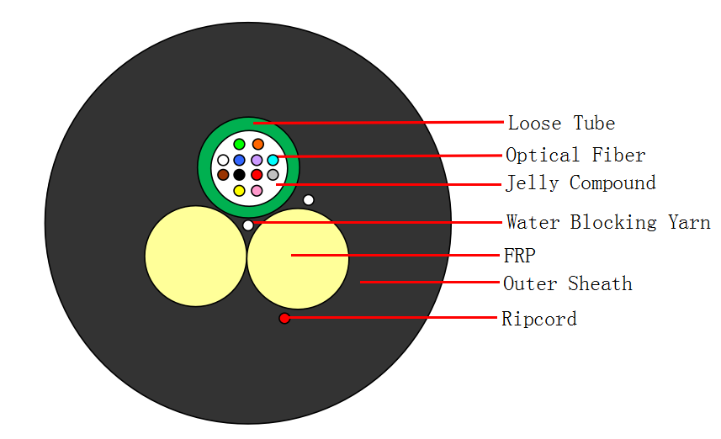
Technical data

Fibers of cable |  | 2~12
Span |  | 120m
Fiber Model |  | G.652D
Loose Tube | Material | PBT
Loose Tube | Diameter | 2.1±0.1 mm
Loose Tube | Thickness | 0.35±0.05 mm
Loose Tube | NO. | 1
Loose Tube | Color | Natural
Strength Member | Material | FRP
Strength Member | Diameter | 2.1±0.05 mm
Strength Member | NO. | 2
Water Blocking | Material | Water Blocking Yarn
Rip Cord | Material | Nylon
Rip Cord | NO. | 1
Outer Sheath | Material | MDPE
Outer Sheath | Color | Black
Cable Diameter |  | 7.4±0.2 mm
Cable Weight |  | 49±5.0 kg/km
Allowable Tensile Strength |  | 2000N
Allowable Crush Resistance |  | 2200N/100mm
Min. bending radius | Without Tension | 12.5×Cable-φ
Min. bending radius | Under Maximum Tension | 25.0×Cable-φ
Temperature range  （℃） | Installation | -20~+60
Temperature range  （℃） | Transport &Storage | -40~+70
Temperature range  （℃） | Operation | -40~+70
Fibre Color

No. | 1 | 2 | 3 | 4 | 5 | 6
Color | Green | Yellow | White | Blue | Red | Violet
No. | 7 | 8 | 9 | 10 | 11 | 12
Color | Brown | Pink | Black | Grey | Orange | Aqua

The properties of single mode optical fiber (ITU-T Rec. G.652.D)

Item | Specification
Fiber type | Single mode
Fiber material | Doped silica
Attenuation coefficient  @ 1310 nm  @ 1383 nm  @ 1550 nm  @ 1625 nm | ≤ 0.35 dB/km  ≤ 0.32 dB/km  ≤ 0.21 dB/km  ≤ 0.25 dB/km
Point discontinuity | ≤ 0.05 dB
Cable cut-off wavelength | ≤ 1260 nm
Zero-dispersion wavelength | 1300 ~ 1324 nm
Zero-dispersion slope | ≤ 0.092 ps/(nm².km)
Chromatic dispersion  @ 1288 ~ 1339 nm  @ 1271 ~ 1360 nm  @ 1550 nm  @ 1625 nm | ≤3.5 ps/(nm. km)  ≤5.3 ps/(nm. km)  ≤18 ps/(nm. km)  ≤22 ps/(nm. km)
PMD_{Q} (Quadrature average*) | ≤0.2 ps/km^{1/2}
Mode field diameter @ 1310 nm | 9.2±0.4 um
Core / Clad concentricity error | ≤ 0.5 um
Cladding diameter | 125.0 ± 0.7 um
Cladding non-circularity | ≤1.0%
Primary coating diameter | 245 ± 10 um
Proof test level | 100 kpsi (=0.69 Gpa), 1%
Temperature dependence  0oC~ +70oC @ 1310 & 1550nm | ≤ 0.1 dB/km

MECHANICAL AND THERMAL PERFORMANCES

DESCRIPTION | VALUES | REFERENCES
Tensile Strength | Load 2000N for 10 minutes  .Variation of attenuation≤0.1dB  .Fibers strain≤0.20% | IEC 60794-1-2-EIA  IEC 60794-1-2-EIB  IEC 60794-2-50
Crush Tset | Load 2000N for 3 minutes  .Variation of attenuation≤0.1dB | IEC 60794-1-2-E3  IEC 60794-2-50
Inpact Test | Energy=1 J on surface of 12.5mm radius,3 times  .Variation of attenuation≤0.1dB | IEC 60794-1-2-E4  IEC 60794-2-50
Bending Test | Load 100N for 5 minutes  Radius of curvature=10×O.D  .Variation of attenuation≤0.1dB | IEC 60794-1-2-E18A  Procedure no.2
Kink Test | No kink with loop diameter of 10 mm | IEC 60794-1-2-E10
Tinght buffer removal | Length of 0.3m in a single operation | IEC 60794-1-2-E5  IEC 60794-1-32
Outer sheath removal | Load≤15N for removing sheath | IEC 60794-2-50  IEC 60793-2-50-E21
Tehrmal Cycles | Range -40℃/+70℃@1550nm  .Variation of attenuation≤0.1dB | IEC 60794-1-2-F1  IEC 60794-2-20
UV Resistant | ±30% after aging | CEI EN 50289-4-17 Method A
Sheath marking

The optical fiber drop cable shall have sequentially numbered length marking at intervals of approximately 1 meter. The starting number of ordering length for any coil shall begin whit zero meter. The accuracy of the measurement of lenth marking shall be held within the limits of ±1%.
- Manufacturer’s name
- Type of wire
- Year and month of manufacture
- Length marking each meter along the wire
HEADWAY GYXFTY-××B1-××m 2024 =0001m=
×

- （b） （c） （d）

