FWA20P-XGS-32XN Series, 32 Ports XG(S)-PON + CATV
Module EDFA
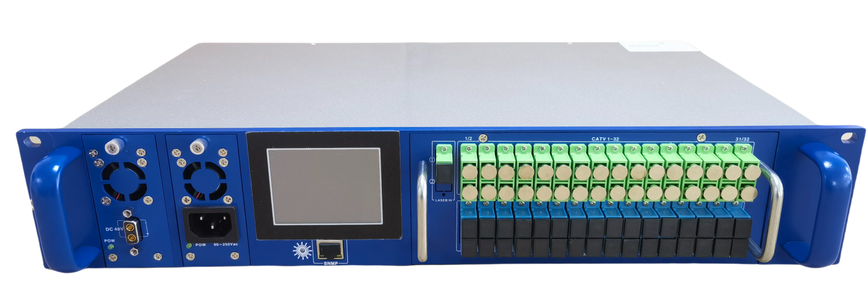
- Product Description
"Quality Broadband" has become the consensus of the development of the global broadband industry. Meeting the needs of users for 10G bandwidth has become a challenge for operators. To meet the challenges faced by operators, Huawei’s next-generation large-capacity distributed intelligent OLT platform MA5800 provides a single service board that supports XGS-PON, XG-PON, and GPON mixed access application scenarios.

Fullwell is a certified solution partner of Huawei. In order to cater to the integration of triply play network and move towards 10G bandwidth, Fullwell has developed the product of XG (S ) -PON + CATV EDFA high power EDFA. Which its CATV signals and XGS-PON, XG-PON and GPON signals can be accessed on one fiber at the same time, helping operators to create all-optical , automated and intelligent FTTH integrated access network, continuously improve user experience, enable quality broadband, help operators CATV and home broadband become possible, while reducing the cost of operator investment.

FWA20P-XGS series is the latest optical transmission system equipment of XG (S) -PON + CATV FTTH / FTTP triple play network integration, and it is the function of combining OLT XG (S) -PON broadband signal and CATV 1550nm optical signal after amplification. Input ports: 1 CATV + 32 XGS-PON / XG-PON and GPON, combined 32 outputs: 1310 / 1490nm & 1270 / 1577nm + 1550nm, of which the total output power range of 1550nm is 27 ~ 45dBm. Multiply output ports can be customized. Compatible with XG (S) -PON / ONU, such as Huawei, ZTE, and Fiberhome, without losing of data, and has a high cost performance.

2. Product feature
◆ Top quality: Adopt JDSU, Ⅱ-Ⅵ multi-mode high-power pump laser and the power is optimized through software, which makes the system achieving excellent CNR AND minimizing the NF of EDFA.
◆ Reliability: 19 ″ 2U chassis, large-screen with touch screen panel, built-in high-performance hot-pluggable dual switching power supply with Chassis automatic heat dissipation control.
◆ Intuitive: JDSU, Ⅱ-Ⅵ multi-mode pump laser is the most expensive component in the device. The built-in microprocessor monitors the working status of the pump laser, and the working parameters are displayed on LCD.
◆ Network management Interface: Web transponder is line with the national standard and compatible with the SCTE HMS standard, achieving WEB monitoring function.
◆ SNMP Support V1 & V2, support both IPv4 and IPv6.
◆ Customizable 2X1 optical switch: built-in optical path selector, 2 optical inputs, can be set to manual or automatic mode for the selection of main and redundant path.
◆ Integrated WDM of XGS-PON, XG-PON and GPON, optical port: XGS-PON, XG-PON and GPON input:
SC/UPC, 1 port of 1550nm CATV optical input port: SC / APC, XG (S) -PON + CATV 1550nm EDFA output optical port: SC / APC. 64/128 multiply output ports can be customized.

- Technical Parameters
Items |  | Unit | Performance Index
Optical Operating Wavelength |  | nm | 1535～1565
Input Optical Power Range |  | dBm | -10～+10
Noise Ratio |  | dB | ≤5.0 (0 dBm,@1550nM)
Gain Flatness |  | dB | ＜±0.3
Optical Power Output Stability |  | dB | ＜±0.5
Polarization Sensitivity |  | dB | ＜0.2
Polarization Mode Dispersion |  | Ps | ＜0.5
Input End Pump Leakage Power |  | dB | ≤-30
Output End Pump Leakage Power |  | dB | ≤-30
Optical Input, Output Return Loss |  | dB | ＞45（APC Stepped Face）
Pump Operating Number |  | PCs | 2～5
Rated Output Power |  | dBm | 27～45
Linker(IN) |  | - | SC/APC or LC/APC
Linker(OUT) |  | - | SC/APC or LC/APC
Power Supply/Consumption |  | V/W | AC90～265 or DC-48/20
Operating/Storage Temperature |  | ℃ | -20～65/-30～70
Operating/Storage Humidity |  | % | 5～90
Chassis Dimension |  | mm | 446×245×86（2U）
Network Management Connector |  | / | RJ45(following national network management standard, supports WEB)
 | XG(S)- PON Wavelength | nm | 1310/1490 & 1270/1577
 | XG(S)- PON Linker | / | SC/UPC or LC/UPC or SC/APC or LC/APC
 | Uplink optical ports | pcs | 32
 | Output ports | Pcs | 32
 | XG(S)- PON Insertion Loss | dB | ＜1.2
 | 1550 Port Insertion Loss | dB | ＜0.7
 | Optical isolation between CATV&OLT | dB | 40
Optical Switch | Insertion Loss | dB | ＜1
Optical Switch | Harass | dB | ＜-60 (isolation between A and B)
Optical Switch | Switch Time | ms | ＜10
Optical Switch | Switched Power Threshold Range | dBm | -5～10

- Product Model Series
Model Number | Total Output Power  dBm(mW) | Output No. | Each Output Power  （dBm）
FWA20P-XGS-16x14 | 28dBm(640mW) | 16 | 14
FWA20P-XGS-32x10 | 28dBm(640mW) | 32 | 10
FWA20P-XGS-16x15 | 29dBm(800mW) | 16 | 15
FWA20P-XGS-32x11 | 29dBm(800mW) | 32 | 11
FWA20P-XGS-16x16 | 30dBm(1000mW) | 16 | 16
FWA20P-XGS-32x12 | 30dBm(1000mW) | 32 | 12
FWA20P-XGS-16x17 | 31dBm(1300mW) | 16 | 17
FWA20P-XGS-32x13 | 31dBm(1300mW) | 32 | 13
FWA20P-XGS-16x18 | 32dBm(1600mW) | 16 | 18
FWA20P-XGS-32x14 | 32dBm(1600mW) | 32 | 14
FWA20P-XGS-16x19 | 33dBm(2000mW) | 16 | 19
FWA20P-XGS-32x15 | 33dBm(2000mW) | 32 | 15
FWA20P-XGS-16x20 | 34dBm(2500mW) | 16 | 20
FWA20P-XGS-32x16 | 34dBm(2500mW) | 32 | 16
FWA20P-XGS-16x21 | 35dBm(3000mW) | 16 | 21
FWA20P-XGS-32x17 | 35dBm(3000mW) | 32 | 17
FWA20P-XGS-16x22 | 36dBm(4000mW) | 16 | 22
FWA20P-XGS-32x18 | 36dBm(4000mW) | 32 | 18
FWA20P-XGS-16x23 | 37dBm(5000mW) | 16 | 23
FWA20P-XGS-32x19 | 37dBm(5000mW) | 32 | 19
FWA20P-XGS-32x20 | 38dBm(6000mW) | 32 | 20
FWA22P-XGS-64x16 | 38dBm(6000mW) | 64 | 16
FWA20P-XGS-32x21 | 39dBm(8000mW) | 32 | 21
FWA22P-XGS-64x17 | 39dBm(8000mW) | 64 | 17
FWA20P-XGS-32x22 | 40dBm(10000mW) | 32 | 22
FWA22P-XGS-64x18 | 40dBm(10000mW) | 64 | 18
FWA20P-XGS-32x23 | 41dBm(13000mW) | 32 | 23
FWA22P-XGS-64x19 | 41dBm(13000mW) | 64 | 19

