机柜空调用户手册 CABINET AIR CONDITIONER USER MANUAL

[产品型号/MODEL: DC0500X2]

※ please read the manual before using the air conditioner.
※ please keep the manual safe after reading.

Contents/目录

- Introduction 5
  - Preface 5
  - Product summary 5
  - Working principle 5
  - Standards 6
- Product function 6
  - Cooling 6
  - Air supply 6
  - Self-inspection 6
- Product parameters 7
  - Product technology parameters 7
  - Product dimension drawing 8
- Installation preparation 8
  - Packing diagram 8
  - Disassemble packing and inspect 9
  - Packing list 9
- Product installation cut size diagram 9
  - Installation diagram 9
  - Installation diagram 10
  - Preparation before installation 10
  - Mechanical installation 11
  - Electrical installation 11
- Interface 12
  - Interface diagram 12
  - Operation instruction 13
  - Parameter set 14
- Product running 15
  - Check before product running 15
  - Product running 15
- Fault analysis and handling 15
  - Fault alarm content and actions 15
  - Common fault analysis and handling 16
- Check and maintenance 18
  - Regular inspection 18
  - Regular maintenance 18
- After-sale service and warranty 19
  - Warranty period 19
  - Warranty range 19
  - Disclaimer 19
Appendix: Electrical Diagram 20
- 简介 21
  - 前言 21
  - 产品概述 21
  - 工作原理 21
  - 符合标准 22
- 产品功能 22
  - 制冷 22
  - 送风 22
  - 自检 22
- 产品参数 23
  - 产品技术参数 23
  - 产品外形尺寸图 24
- 安装准备 24
  - 包装示意图 24
  - 拆除包装及检查 25
  - 装箱清单 25
- 产品安装 25
  - 机柜开孔尺寸图 25
  - 安装示意图 26
  - 安装前准备 26
  - 机械安装 27
  - 电气安装 27
- 人机界面 28
  - 界面示意图 28
  - 操作说明 28
  - 参数设置 29
- 产品运行 30
  - 产品运行前检查 30
  - 产品运行 30
- 故障分析与处理 31
  - 故障告警内容及响应动作 31
  - 常见故障分析与处理 31
- 维护与保养 33
  - 定期检查 33
  - 定期维护 33
- 售后服务与保修 33
  - 保修期 34
  - 保修范围 34
  - 免责声明 34
附录：电气原理图 35

Introduction

Preface
This manual introduces the important methods to use cabinet air conditioner. Please read carefully the manual before using and following the usage and note to make sure use the cabinet air conditioner safely and correctly. After reading, please keep the manual safe for reference at any time.

Product summary
The air conditioner is one kind of refrigeration product self-developed for communication cabinet. It is applicable in the place where the cabinet internal heat is very large, the internal electronic equipment is sensitive to the environment temperature and which should be isolated internally and externally completely. This product has multiple functions, high reliability, and has the feature that it can start to work without complex debugging after powering.

Working principle
After powering on, the low pressure steam from the refrigerant in the refrigeration system is inhaled by compressor, compressed into high pressure steam and then discharged to the condenser. Meanwhile, the air inhaled by external fan goes through condenser and takes away the heat given off by refrigerant and makes high pressure refrigerant steam condensed into high pressure liquid. High pressure liquid is sprayed into evaporator by throttle device and evaporated under the corresponding low pressure and absorbs the heat around. Meanwhile, the fan in cabinet makes air heat exchange by evaporator fins and sends the cooled air into cabinet. By so, the air in cabinet can cycle to achieve the purpose of lowering the temperature.





Compressor
Heat
Heat
Condenser
Evaporator
Throttling

Standards

No. | Standard No. | Standard Name
01 | GB 4208 | Enclosure Protection Class
02 | GB4706.1 | Safety of household and similar electrical  appliances
03 | GB 9237-2001 | Mechanical refrigerating systems Used for cooling  and heating--Safety requirements
04 | GB/T17626.8 | Electromagnetic compatibility-Testing and  measurement techniques--Power frequency magnetic field immunity test
05 | GB/T 4798.1、2、3 | Environmental conditions existing in application  of electric

Product function

Cooling
Air conditioner can be set parameters by display or backend software: refrigeration starting temperature and refrigeration stopping temperature. When the temperature inside cabinet is higher than refrigeration starting temperature, it starts refrigerating; when the temperature inside cabinet is lower than refrigeration stopping temperature, it stops refrigerating.

Refrigerating Parameter Set

Parameter | Default value | Set Scope | Unit
Refrigeration starting  temperature | 30 | [20～40] | ℃
Refrigeration stopping  temperature | 25 | [15～35] | ℃
Note: Refrigeration starting temperature≥ Refrigeration stopping temperature+3℃ and above

Air supply
Air conditioner can make the temperature inside cabinet uniform by air supply and avoid partial overheating. When cabinet inside cabinet is lower refrigeration starting temperature, the air supply function starts automatically.

Self-inspection
By interface’s function key, enter into self-inspection menu and system starts self inspection. Function key: Prg/mute enter key: Set
Self inspection process logic as following:
- Inspect sensor for 2s；
- Internal fan runs 20s under full speed;
- External fan and compressor run 30s;
- Quit self inspection function, Icon stop, internal, external fan and compressor continue to run for 150s;

- Then Judge refrigeration conditions.

Product parameters

Product technology parameters

Item | Unit | Parameter
Working environment temperature | ℃ | -15 ～ +55
Rated DC input voltage | VDC | -48
Rated DC input power | W | 180
Rated DC input current | A | 3.8
Maximum working current | A | 7
Refrigerating capacity(L35/L35) | W | 580
Body outline dimension (width*height*depth ) | mm | 320*550*171
Outline dimension including  flange(width*height*depth ) | mm | 353*583*171
Net weight | Kg | 14.5
Installation method | — | Embedding slightly
The largest sound pressure level noise (1.5m far and  1.2m high from the air conditioner) | dB(A) | 62
IP grade | — | IP55
Refrigerant | — | R134a/130g
Life | Years | >10
Surface treatment | — | Electrostatic coating

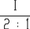
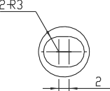
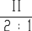
Product dimension drawing
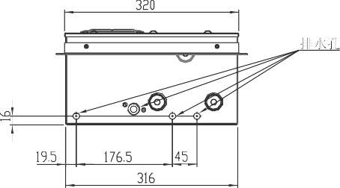
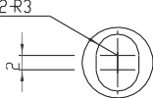
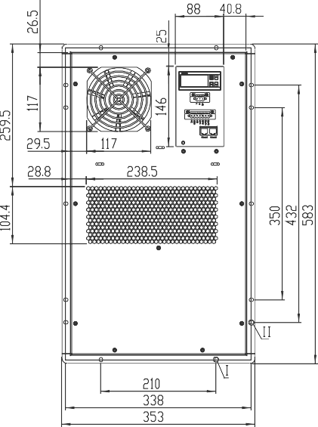
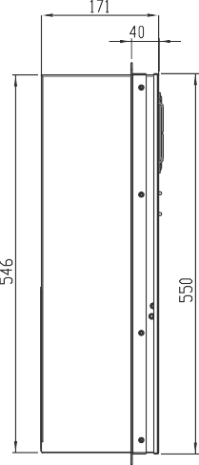
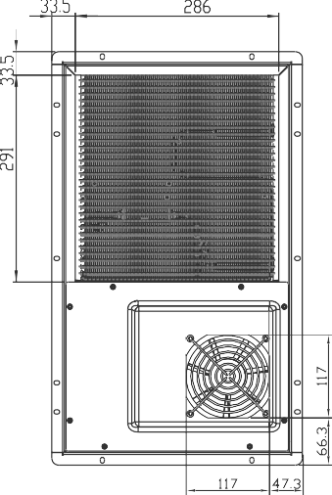

Installation preparation

Packing diagram
The packing includes the bottom pallet, top protection plate, wrapping film and packing belt. The packing diagram is as following:
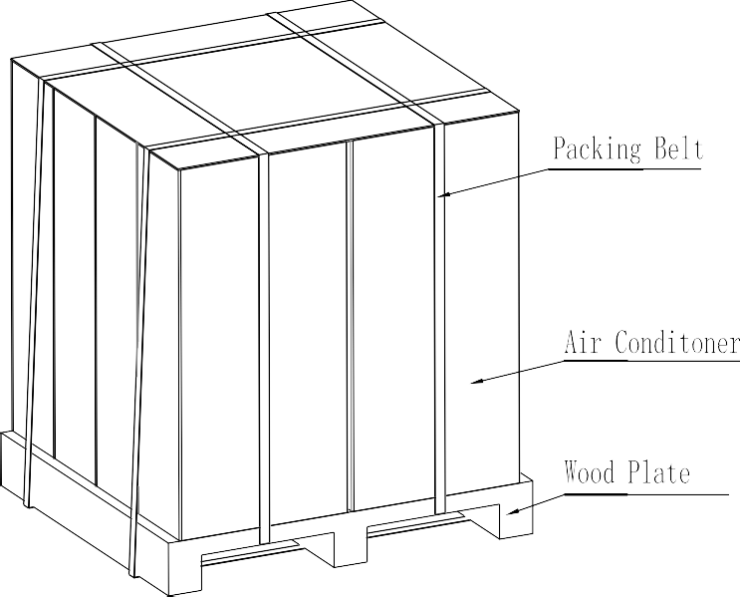

Disassemble packing and inspect
568
432
350
552(height of hole) 583(height of flange)
- Prepare tools to disassemble: protective gloves, scissors and knives;
- Wear protective gloves, remove wrapping film and packing belt;
- Take air conditioner and make OBA: check whether the air conditioner model is right and the appendix is complete;
- Please read carefully the 5.3 article-Preparation before installation in the manual in order to finish installation successfully.

Packing list

No. | Name | Qty | Note
1 | Cabinet air conditioner | 1
2 | Manual | 1
3 | DC power wire | 1 | 3.5m
4 | Alarming wire | 1 | 3.5m

Product installation cut size diagram

Installation diagram
338
210
14-CLS-M5-1
The shade area should be cut off
322(width of hole)
353(width of flange)

Installation diagram
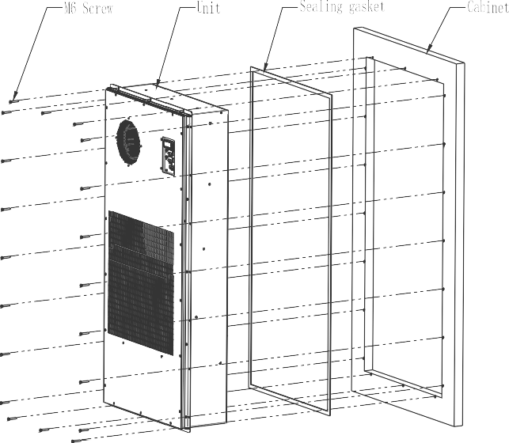
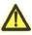 Note: the installation diagram is just for reference. It depends on the site condition to install.

Preparation before installation
- Installation notes:
- Keep air conditioner vertical during installation, the inclination is less than 3°;
- When moving, handle with care and avoid collision in case of scratching the surface coating;
- After removing package, check whether the cosmetic is good, if damaged or deformed, please contact professional personnel to check and repair;
- Count the accessory according to the appendix list and prepare installation tools;
- When choosing installation place, make sure the ventilation is good, keep the distance from air-out side to equipments inside cabinet more than 30cm, otherwise, it may cause short circuit and bad heat exchange effect;
- The mechanical and electrical installation should be operated by professional person strictly referring the manual;
- Check whether air conditioner drainage loop is smooth, in case that drainage is blocked;
- To build clean and environmental installation site, please recycle the package after installation.

Preparation installation tools

No. | Name | Qty | Note
1 | Cross screwdriver | 1 | M5
2 | Slotted point screwdriver | 1 | M3
3 | Multimeter | 1
4 | Wire stripper | 1
5 | Wire crimper | 1
6 | Tape | 1

Mechanical installation
- Choose cut location on cabinet door according to cabinet cut size, remove the shadow area and make the corresponding air conditioner installation hole.
- Place air conditioner at the cut location as installation diagram, make air conditioner flange close to cabinet door, fix it with M5 stainless steel screwdriver.
- Check whether air conditioner is installed levelly, firmly and finish the mechanical installation.

Electrical installation
DC power supply input port, I/O port, RJ45 communication port
- DC power supply input port
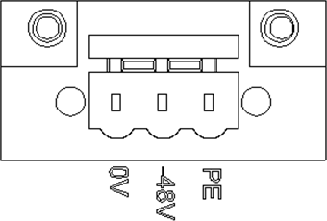

DC power supply input port | Definition
0V | DC power supply+
-48V | DC power supply-
PE | Earth wire
- I/O port
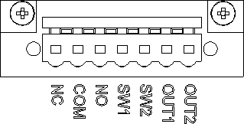

I/O port | Definition | Note
NC | Dry contact output  normally closed port | Close during normal running, disconnect during alarm or power failure
COM | Dry contact output  common port | Dry contact alarm output common port
NO | Dry contact output  normally open port | Reserved
SW1 | Alarm input | Reserved
SW2 | Alarm input | Reserved
OUT1 | Alarm output | Reserved
OUT2 | Alarm output | Reserved

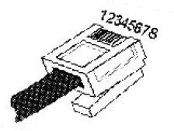
- RJ45communication port

RJ45communication port | Definition
1、4 | RS485+(A)
2、5 | RS485-(B)
3、6、7、8 | Backup port

Interface

Interface diagram
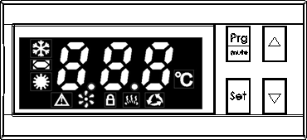

No. | 图标 | Function | Function explanation
1 |  | Refrigerating running | Shows whether refrigerating runs
2 |  | Alarming | Shows whether air conditioner alarms
3 |  | Starting running | Shows whether air conditioner is on or not
4 |  | Fan running | Shows whether fan runs
5 | -8.8.8 | Temperature/fault | Shows temperature value or fault mark contents
6 | Prg/mute | Function key | Function selection key or backspace key（from low level menu to high level menu）
7 | Set | enter key | Select function and enter parameter set
8 | ▲ | Up key | Increase value, page up
9 | ▼ | Down key | Decrease value, page down

Operation instruction
    - Standby
Under standby status, no press any key for 1 minute to enter into power saving mode and turn off LED, show mark. Press any key to quit power saving mode and turn on LED.
Under running status, the ’-8.8.8 ’ in the main interface shows the temperature value outside
cabinet.The unit is ℃.

Switch on/off
Under off status, press Up key：▲ for 5s to start refrigeration system. Under on status, press down key ▼ 5s to stop refrigeration system.

Function selection
Under standby status, press Prg/mute, function mark will shown at ’-8.8.8 ’ area. Function key：Prg/mute Up key：▲ or Down key：▼
Press Up key：▲ or Down key：▼, it will show ’ ’、 ’ ’、 ’ ’、 ’ ’ successively, press Prg/mute again back to main interface.

Self-inspection
Start self-inspection function by the below methods： Function key：Prg/mute enter key：Set The Mark shows the self inspection starts.

Sensor temperature inquiry
The sensor temperature can be inquired by following methods:
Function key：Prg/mute enter key：Set Up key：▲ or Down key：▼ Press Up key：▲ or Down key：▼, it will show 1 2 3 4successively and several seconds later, the temperature sensor value can be shown. Press Function key:
、
、
、
Prg/mute back to the main interface.

Code | Fault name | Note
1 | Temperature in cabinet | NTC1
2 | Condenser middle part temperature | NTC2
3 | Working temperature | NTC3
4 | Evaporator middle part temperature | NTC4

Fault alarm inquiry
When there is alarm, the mark is on. The fault alarm can be inquired by follow methods: Function key：Prg/mute enter key：Set Up key：▲ or Down key：▼

Fault alarm code will be shown at ’-8.8.8 ’ area. If several alarms one time, they will be shown successively at ’-8.8.8 ’ area. Press Function key：Prg/mute back to the main interface.
Fault name | Fault code | Fault name | Faul  t code
cabinet temperature sensor fault | E1 | Evaporator freezing up | E8
Evaporator middle part temperature sensor fault | E2 | Fan fault | E9
Condenser middle part temperature sensor fault | E3 | Heater fault(without this feature) | E10
Environment temperature sensor fault | E4 | Compressor fault | E11
voltage is too high or too low | E5 | Inverter communication fault | E12
Temperature in cabinet is too high or too low | E6 | Humidity sensor failure(without  this feature) | E13
System high pressure alarm | E7 | Humidity alarm(without this  feature) | E14
The smoke alarm(without this feature) | E15

Parameter set
Function key：Prg/mute Enter key：Set，enter into the interface for password input.
    - Password input
      - under this interface, press Function key：Prg/mute to return to main interface, without saving parameter;
      - Press enter key：Set to numerical shift;
      - Press Up key：▲ or Down key: ▼ to increase or decrease value.

Name | Value | Unit | Default | Note
User password | 123 | -- | -- | User parameter set
    - User set
Function key：Prg/mute enter key：Set Up key：▲ or Down key：▼
enter key：Set，enter into user set interface.
After entering user set interface, press Up key：▲ or Down key：▼ to shown S1、S2……S6 successively. Choose the corresponding code to enter and set parameter. After setting, save it. Press Function key：Prg/mute back to the main interface.
Code | Name | Value | Unit | Default | Definition
S1 | Refrigeration starts | 20～40 | ℃ | 30 | Air conditioner running starting  temperature
S2 | Refrigeration stops | 15～35 | ℃ | 25 | Air conditioner running

 |  |  |  |  | stopping temperature
S3 | High temperature  alarm | 30～60 | ℃ | 40 | High temperature alarm  temperature
S4 | Low temperature  alarm | -45～10 | ℃ | 0 | Low temperature alarm  temperature
S5 | Set address | 1～254 | / | 40 | Select set address
S6 | Set baud rate | 0～4 | / | 3 | 0:1200 1:2400  2:4800 3:9600  4:19200

Product running

Check before product running
- Check whether air conditioner is installed as direction in installation diagram and is not installed upside down;
- Check whether air conditioner structure is complete, installation is stable or not;
- Check whether air conditioner input power, dry contact alarm output and communication cable are installed as electrical installation requirement and whether connector is plugged wrong or loss;
- Check whether cabinet input power voltage and frequency meets the requirement of air conditioner.
- After checking, prepare to run.

Product running
After air conditioner is powered on, it will start self inspection. Please refer to the 2.3 in the manual for the self inspection process. After self inspection, if there is no system alarm, air conditioner will automatically judge whether it meets the running logic according to the inspected internal recycling air outlet temperature. If there is alarm, please refer the 8.1 in the manual to judge the exact alarm and analyze and handle as the 8.2 in the manual. Then handle by self or contact vendor to repair.

Fault analysis and handling

Fault alarm content and actions

Fault status | Default value | Reset mode | Whether output from dry contact
Temperature sensor fault in the middle part of  condenser | — | Automatic | No
Temperature sensor fault outside cabinet | — | Automatic | No
Temperature sensor fault in the middle part of  evaporator | — | Automatic | No
Temperature sensor fault inside cabinet | — | Automatic | No
System high pressure alarm | — | Automatic | Yes
Evaporator freezing up | — | Automatic | Yes
Temperature in cabinet is too high | 40℃ | Automatic | Yes

Temperature in cabinet is too low | 0℃ | Automatic | No
DC voltage is too high | 6 V | Automatic | No
DC voltage is too low | V | Automatic | No
Compressor fault | — | Automatic | No
Power fail alarm | — | Automatic | Yes
Internal fan fault | — | Automatic | No
External fan fault | — | Automatic | No
Inverter communication fault | — | Automatic | No
Heater fault(without this feature) | — | Automatic | No
Humidity alarm(without this feature) | 90% | Automatic | No
The smoke alarm(without this feature) | — | Automatic | No

Common fault analysis and handling

Fault status | Cause analysis | Fault handling
Temperature sensor fault in the middle part  of condenser | - sensor fault broken down or short circuit;  - Sensor damaged | - Check sensor circuit;  - Change sensor.
Temperature  sensor fault outside cabinet | - sensor fault broken down or short circuit;  - Sensor damaged | - Check sensor circuit;  - Change sensor.
Temperature sensor fault in the middle part  of evaporator | - sensor fault broken down or short circuit;  - Sensor damaged | - Check sensor circuit;  - Change sensor.
Temperature  sensor fault inside cabinet | - sensor fault broken down or short circuit;  - Sensor damaged | - Check sensor circuit;  - Change sensor.
System high pressure alarm | - Condenser is jammed or scaled;  - External fan fault;  - external air recycling short circuit or shaded;  - Add too much refrigerant when repairing;  - Working temperature is too high;  - False alarm by sensor in the middle part of condenser; | - Regularly clean condenser heat exchanger; 2.Check/change condensing fan;  - External cover air inlet and outlet should be separated well, make sure there is no shade at front;  - Ask professional person to repair and add proper refrigerant by nameplate requirement;  - Reduce working temperature properly, or add shading device;．  - Change sensor in the middle part of

 |  | condenser;
Evaporator freezing up | - Internal air recycling short circuit;  - Air inlet and outlet is not smooth；  - Internal fan fault;  - refrigeration system cannot be turned off;  - False alarm by sensor in the middle part of evaporator; | - make sure there is some distance from internal recycling air inlet to equipments in cabinet and  Add partition;  - Make sure internal recycling air inlet and outlet smooth and no serious block;  - Change internal fan;  - Check refrigeration system main control board and related electric;  - Change temperature sensor
Temperature in cabinet is too high | - Condenser is jammed or scaled;  - Working temperature is too high;  - Refrigeration system fault;  - New equipment with large heating capacity; 5.Temperature is set improperly;  6. False alarm by temperature  sensor in cabinet | - Regularly clean condenser heat exchanger;  - Reduce working temperature properly, or add shading device;．  - Ask professional personnel to inspect and repair;  - Re-evaluate heating capacity and adjust;  - Re-evaluate temperature set value and deviation;  - Change temperature sensor
Temperature in cabinet is too low | - Temperature is set improperly;  - Refrigeration system cannot be turned off;  - False alarm by temperature  sensor in cabinet | - Re-evaluate temperature set value and deviation;  - Check whether refrigeration system main control board and relay contact are adjoined;  - Change temperature sensor
voltage is too high or too low | - DC voltage spec-out;  - DC power off;  - Voltage deviation module damaged;  - Internal circuit  disconnecting | - Check DC power or voltage;  - Re-power on  - Change voltage deviation module;  - Check circuit
Compressor fault | - Condenser is jammed or scaled;  - Rough handling impact ; | - Regularly clean condenser heat exchanger;  - Move vertically and handle with care;
Internal fan  fault | - Internal fan stalls;  - Internal fan damaged | Change internal fan
External fan  fault | - External fan stalls;  - External fan damaged. | Change external fan
Inverter  communication | - Communication wire does not connect properly or break | - Check communication wire and change it if necessary;

fault | 2. Inverter or main PCB breaks | 2. Check inverter and main PCB, and change  them if necessary

Check and maintenance

Regular inspection
For checking the operating condition of the cabinet air conditioner , please check the cabinet air conditioner regularly referring to the following table.
Item | Step | Period
Wire | Check whether cabinet air conditioner power supply wire and communication wire is Ok or not; | 3 month
Air temperature | Check whether cabinet air conditioner running is normal, whether the air inlet and air outlet mouth temperature difference is obvious when starting refrigeration system | 3 month
Fan | Check whether fans work normally and whether there is obvious noise or shake | 3 month
Structural parts | Check whether mechanical structural parts are damaged or deformed | 3 month
Inner and outer circulation | Check whether air conditioner inner and outer circulation air inlet and outlet are jammed | 3 month
Drain pipe | Check whether drain pipe is jammed | 3 month
Warning :
- Inspections above are visual inspections. Please do not touch the cabinet air conditioner when the cabinet air conditioner running .
- Please call the professional when the cabinet air conditioner is not running normally .
- Please cut off the power supply before maintenance.

Regular maintenance
For the normal operation of the cabinet air conditioner, please mainten the cabinet air conditioner regularly referring to the following table.
Item | Step | Period
Wire | Check whether the wire inside the cabinet air conditioner is Ok or not; | 12 month
Fan | Toggle the fan , and check whether there is obvious noise or friction | 12 month
Structural parts | Check whether mechanical structural parts inside are damaged or deformed | 12 month
Drain pipe | Check whether drain pipe is jammed and clean with compressed air | 6 month
Inner and outer circulation | Check whether air conditioner inner and outer circulation air inlet and outlet are jammed and clean | 3-6 month

 | with compressed air
Heat exchanger | Check whether heat exchanger is jammed and clean with compressed air | 3-6month
Warning:
- The cabinet air conditioner should be maintained by professional. Please cut off the power supply before maintenance.
- Please shorten the maintenance period of heat exchanger and inner and outer circulation when the air pollution is severe .
- Do not clean the equipment inside the cabinet air conditioner with hot water or organic solvent .

After-sale service and warranty

Warranty period
Under the condition using cabinet air conditioner correctly, the contracted warranty period shall prevail.

Warranty range
During warranty period, manufacture will repair for free the quality faults caused by product itself and customer should provide the S/N. But the faults under below conditions are out of warranty for free:
- Warranty period expire;
- S/N cannot be provided;
- Faults caused under abnormal condition or circumstance, or caused by improper installation, maintenance or other operations;
- Faults not caused by air conditioner itself, such as the user's equipment, software and others;
- Damaged caused by replacing or disassembling by user, or by unauthorized repairing service persons;
- Faults caused by majeure force such as fire, earthquake, flood and others.

Disclaimer
The warranty is only for the delivered products. Air conditioner manufacturer is responsible for any loss which is derived from equipment fault.

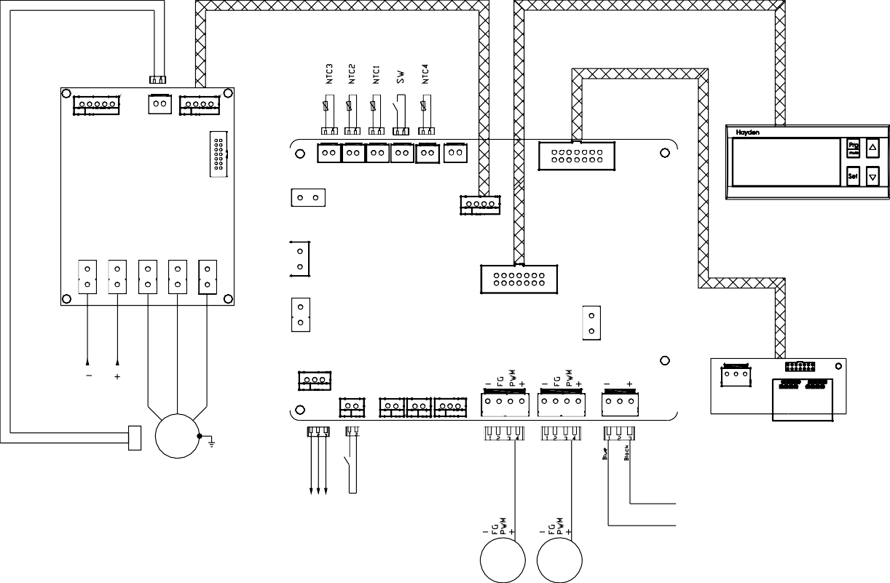
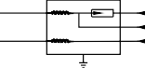
Appendix: Electrical Diagram
Temperature Sensor
Thermal Inverter Switch Communication Port
LED
INVERTER
Communication Wire
Inverter
communication port
LED Wire
DC 48V
48VDC
W V U
RJ45
COMP
Thermal
switch
EMI Filter
lightning protection PCB
48VDC
SPD
PE
0V
-48V
Int Fan
Ext Fan

FILTER
Evaporator
Reserved Input
Interior
Condensor
Exterior
P-
P+
W
V
U
COM NO NC
Alarm
OUT
Reserved Output
COM NO
ALARM GND
FG1 FG2 PWM
Interior Fan
Exterior Fan
LOAD
LINE

