Booster amplifier: Optical EDFA Amplifier Unit

The EDFA Booster amplifier is an erbium-doped fiber amplification card launched by Sintai Communication, main function is to compensate the power of the signal light in the transmitting end of the transmission link, and it can amplify the optical signals of up to 48 channels (channel interval of 100 GHZ) or 96 channels (channel interval of 50 GHZ) at C band at the same time. It has characters of flat gain, locked gain, low noise figure, etc. and it’s an indispensable important component for DWDM system, future high speed system and all-optical network long-distance transmission.

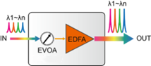

Product specification
Function | Description
Working wavelength range | Standard type: 1529nm~1561nm  Applicable to 40 wavelength(100GHz) or 80 wavelength(50GHz) DWDM system
Extension type: 1528nm~1568nm
Applicable to 48 wavelength(100GHz) or 96 wavelength(50GHz) DWDM system
Min input optical power | -30 dBm
Max output power | +22dBm
Max Gain | 30dB, special gain can be customized
Noise factor | ＜5.5dB
Gain flatness | ＜1.5dB
Secondary amplification | Support built-in dual pump (optional) for signal secondary amplification
Unique technology | Support gain locking technology, transient control technology automatic shut-off technology of output optical power
EVOA function | Built-in EVOA (optional); network management can adjust dynamic damping range of 0~15dB
Network management function | - Support real time monitoring for EDFA port working state, including: optical power, optical pumping, temperature, etc.  - Support pump shutdown threshold and automatic recovery time setting function
Occupied slot number | Support OTNS8600 series chassis, occupy 1 slot
Optical interface | LC/UPC, special interface can be customized
Max power consumption | 15W
MTBF | ＞100000 hours

Pre-amplifier: Optical EDFA Amplifier Unit

The EDFA Pre-amplifier is an erbium-doped fiber amplification card launched by Sintai Communication, main function is to compensate the power of the signal light in the receiving end of the transmission link, and it can amplify the optical signals of up to 48 channels (channel interval of 100 GHZ) or 96 channels (channel interval of 50 GHZ) at C band at the same time. It has characters of flat gain, locked gain, low noise figure, etc. and it’s an indispensable important component for DWDM system, future high speed system and all-optical network long-distance transmission.

Product specification
Function | Description
Working wavelength range | Standard type: 1529nm~1561nm  Applicable to 40 wavelength(100GHz) or 80 wavelength(50GHz) DWDM system
Extension type: 1528nm~1568nm
Applicable to 48 wavelength(100GHz) or 96 wavelength(50GHz) DWDM system
Min input optical power | -30 dBm
Max output power | +22dBm
Max Gain | 30dB, special gain can be customized
Noise factor | ＜5.5dB
Gain flatness | ＜1.5dB
Secondary amplification | Support built-in dual pump (optional) for signal secondary amplification
Unique technology | Support gain locking technology, transient control technology automatic shut-off technology of output optical power
EVOA function | Built-in EVOA (optional); network management can adjust dynamic damping range of 0~15dB
Network management function | - Support real time monitoring for EDFA port working state, including: optical power, optical pumping, temperature, etc.  - Support pump shutdown threshold and automatic recovery time setting function
Occupied slot number | Support OTNS8600 series chassis, occupy 1 slot
Optical interface | LC/UPC, special interface can be customized
Max power consumption | 15W
MTBF | ＞100000 hours

In-line amplifier: Optical EDFA Amplifier Unit

The EDFA In-line amplifier is an erbium-doped fiber amplification card launched by Sintai Communication, main function is to compensate the power of the signal light in the middle of the transmission link when pre-amplifier and booster amplifier might not be enough, and it can amplify the optical signals of up to 48 channels (channel interval of 100 GHZ) or 96 channels (channel interval of 50 GHZ) at C band at the same time. It has characters of flat gain, locked gain, low noise figure, etc. and it’s an indispensable important component for DWDM system, future high speed system and all-optical network long-distance transmission.

Product specification
Function | Description
Working wavelength range | Standard type: 1529nm~1561nm  Applicable to 40 wavelength(100GHz) or 80 wavelength(50GHz) DWDM system
Extension type: 1528nm~1568nm
Applicable to 48 wavelength(100GHz) or 96 wavelength(50GHz) DWDM system
Min input optical power | -30 dBm
Max output power | +22dBm
Max Gain | 30dB, special gain can be customized
Noise factor | ＜5.5dB
Gain flatness | ＜1.5dB
Secondary amplification | Support built-in dual pump (optional) for signal secondary amplification
Unique technology | Support gain locking technology, transient control technology automatic shut-off technology of output optical power
EVOA function | Built-in EVOA (optional); network management can adjust dynamic damping range of 0~15dB
Network management function | - Support real time monitoring for EDFA port working state, including: optical power, optical pumping, temperature, etc.  - Support pump shutdown threshold and automatic recovery time setting function
Occupied slot number | Support OTNS8600 series chassis, occupy 1 slot
Optical interface | LC/UPC, special interface can be customized
Max power consumption | 15W
MTBF | ＞100000 hours

Optical Module: 100G QSFP28 DWDM（2λ）
Features
- Supports 100Gbps
- Applicable to C-Band 50GHz DWDM wavelength as defined by ITU-T standard
- Transmission distance up to 80km (with EDFA and DCM)
- Compliant with QSFP28 MSA standard
- Integrated SFEC capability with high coding gain
- 4x25G CAUI4 electrical interfaces
- Dual CS optical interfaces
- I2C interface with integrated digital diagnostics
- Supply voltage: 3.3V
- Operating temperature: 0°C to +70°C
- Power consumption: <5W
- RoHS-6 compliant (lead-free)

Applications
- 100GE over DWDM
- Data Center Interconnection
The 100G QSFP28 DWDM (2λ) optical module from Sintai Communication Co., Ltd. is designed for 80km data center interconnection in metro area. The module can convert 4 x 25Gbps (NRZ) electrical signals to 2 x 50Gbps (PAM4) optical signals, and also convert 2 x 50Gbps (PAM4) optical signals to 4 x 25Gbps (NRZ) electrical signals, providing a total of 96 nominal DWDM wavelengths (50GHz interval) in the C-Band 191.30THz~196.05THz range, intended for deployment in DWDM network equipment in metro access and core networks. The electrical interface of the module is QSFP28 MSA compliant.
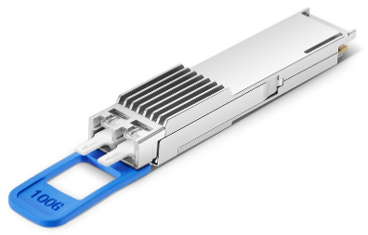

Package | Model | Rate | Transmitting optical power | Receiving sensitivity | Interface
QSFP28 | ST-QDCZ-C13/14² | 103.125Gbps | -1 ~ +4dBm | -12.5dBm@BER 4E-3 | Dual CS
Detailed wavelength information of each type of optical module is shown in the following table

Model Code | Transmitter 1 |  |  | Transmitter 2
 | Channel No. | Center Frequency （THz） | Central Wavelength （nm） | Channel No. | Center Frequency （THz） | Central Wavelength （nm）
ST-QDCZ-C13/14 | C13 | 191.30 | 1567.13 | C14 | 191.40 | 1566.31
ST-QDCZ-H13/14 | H13 | 191.35 | 1566.72 | H14 | 191.45 | 1565.90
ST-QDCZ-C15/16 | C15 | 191.50 | 1565.50 | C16 | 191.60 | 1564.68
ST-QDCZ-H15/16 | H15 | 191.55 | 1565.09 | H16 | 191.65 | 1564.27
ST-QDCZ-C17/18 | C17 | 191.70 | 1563.86 | C18 | 191.80 | 1563.05
ST-QDCZ-H17/18 | H17 | 191.75 | 1563.45 | H18 | 191.85 | 1562.64
ST-QDCZ-C19/20 | C19 | 191.90 | 1562.23 | C20 | 192.00 | 1561.42
ST-QDCZ-H19/20 | H19 | 191.95 | 1561.83 | H20 | 192.05 | 1561.01
ST-QDCZ-C21/22 | C21 | 192.10 | 1560.61 | C22 | 192.20 | 1559.79
ST-QDCZ-H21/22 | H21 | 192.15 | 1560.20 | H22 | 192.25 | 1559.39
ST-QDCZ-C23/24 | C23 | 192.30 | 1558.98 | C24 | 192.40 | 1558.17
ST-QDCZ-H23/24 | H23 | 192.35 | 1558.58 | H24 | 192.45 | 1557.77
ST-QDCZ-C25/26 | C25 | 192.50 | 1557.36 | C26 | 192.60 | 1556.55
ST-QDCZ-H25/26 | H25 | 192.55 | 1556.96 | H26 | 192.65 | 1556.15
ST-QDCZ-C27/28 | C27 | 192.70 | 1555.75 | C28 | 192.80 | 1554.94
ST-QDCZ-H27/28 | H27 | 192.75 | 1555.34 | H28 | 192.85 | 1554.54
ST-QDCZ-C29/30 | C29 | 192.90 | 1554.13 | C30 | 193.00 | 1553.33
ST-QDCZ-H29/30 | H29 | 192.95 | 1553.73 | H30 | 193.05 | 1552.93
ST-QDCZ-C31/32 | C31 | 193.10 | 1552.52 | C32 | 193.20 | 1551.72
ST-QDCZ-H31/32 | H31 | 193.15 | 1552.12 | H32 | 193.25 | 1551.32
ST-QDCZ-C33/34 | C33 | 193.30 | 1550.92 | C34 | 193.40 | 1550.12
ST-QDCZ-H33/34 | H33 | 193.35 | 1550.52 | H34 | 193.45 | 1549.72
ST-QDCZ-C35/36 | C35 | 193.50 | 1549.32 | C36 | 193.60 | 1548.51
ST-QDCZ-H35/36 | H35 | 193.55 | 1548.91 | H36 | 193.65 | 1548.11
ST-QDCZ-C37/38 | C37 | 193.70 | 1547.72 | C38 | 193.80 | 1546.92
ST-QDCZ-H37/38 | H37 | 193.75 | 1547.32 | H38 | 193.85 | 1546.52
ST-QDCZ-C39/40 | C39 | 193.90 | 1546.12 | C40 | 194.00 | 1545.32
ST-QDCZ-H39/40 | H39 | 193.95 | 1545.72 | H40 | 194.05 | 1544.92
ST-QDCZ-C41/42 | C41 | 194.10 | 1544.53 | C42 | 194.20 | 1543.73
ST-QDCZ-H41/42 | H41 | 194.15 | 1544.13 | H42 | 194.25 | 1543.33
ST-QDCZ-C43/44 | C43 | 194.30 | 1542.94 | C44 | 194.40 | 1542.14
ST-QDCZ-H43/44 | H43 | 194.35 | 1542.54 | H44 | 194.45 | 1541.75
ST-QDCZ-C45/46 | C45 | 194.50 | 1541.35 | C46 | 194.60 | 1540.56
ST-QDCZ-H45/46 | H45 | 194.55 | 1540.95 | H46 | 194.65 | 1540.16
ST-QDCZ-C47/48 | C47 | 194.70 | 1539.77 | C48 | 194.80 | 1538.98
ST-QDCZ-H47/48 | H47 | 194.75 | 1539.37 | H48 | 194.85 | 1538.58
ST-QDCZ-C49/50 | C49 | 194.90 | 1538.19 | C50 | 195.00 | 1537.40
ST-QDCZ-H49/50 | H49 | 194.95 | 1537.79 | H50 | 195.05 | 1537.00
ST-QDCZ-C51/52 | C51 | 195.10 | 1536.61 | C52 | 195.20 | 1535.82
ST-QDCZ-H51/52 | H51 | 195.15 | 1536.22 | H52 | 195.25 | 1535.43
ST-QDCZ-C53/54 | C53 | 195.30 | 1535.04 | C54 | 195.40 | 1534.25
ST-QDCZ-H53/54 | H53 | 195.35 | 1534.64 | H54 | 195.45 | 1533.86
ST-QDCZ-C55/56 | C55 | 195.50 | 1533.47 | C56 | 195.60 | 1532.68
ST-QDCZ-H55/56 | H55 | 195.55 | 1533.07 | H56 | 195.65 | 1532.29
ST-QDCZ-C57/58 | C57 | 195.70 | 1531.90 | C58 | 195.80 | 1531.12
ST-QDCZ-H57/58 | H57 | 195.75 | 1531.51 | H58 | 195.85 | 1530.72
ST-QDCZ-C59/60 | C59 | 195.90 | 1530.33 | C60 | 196.00 | 1529.55
ST-QDCZ-H59/60 | H59 | 195.95 | 1529.94 | H60 | 196.05 | 1529.16

OTDQ3: 40G&100G Transponder/OEO Card

The 40G&100G Transponder service access board from Sintai Communication supports three 40G or 100G services access, its main function is to 3R regenerate the three 40G or 100G service signals and convert them into three WDM standard wavelength optical signals, so that the wave combining unit can perform WDM on the optical signals of different wavelengths, and to realize the reverse process of the above. WDM short-range transmission solution for 40G or 100G rate in metro area.

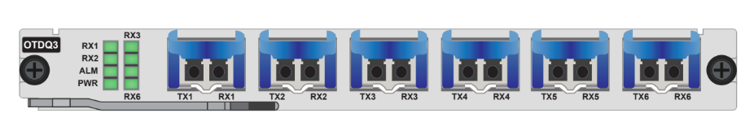
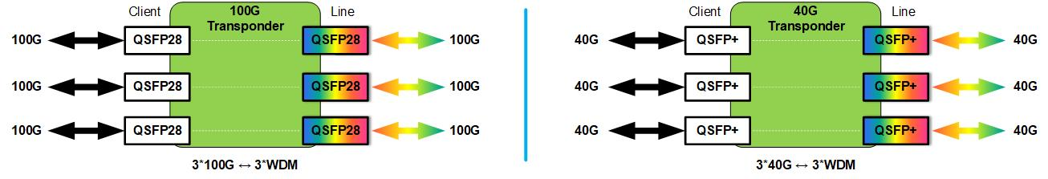

Product specifications
Parameter | Description
Product model | OTDQ3
Application | 100G wavelength conversion | 40G wavelength conversion
Interface | Client-side: 3, based on QSFP28 pluggable  Line-side: 3, based on QSFP28 pluggable | Client-side: 3, based on QSFP+ pluggable  Line-side: 3, based on QSFP+ pluggable
Line mode | Supports 3*100G service transparent transmissions, which can transform 3*100G service optical signals into 3*WDM standard wavelength optical signals | Supports 3*40G services for transparent transmission, which can transform 3*40G service optical signals into 3*WDM standard wavelength optical signals
Support service type | 100GE  OTU4 | 40GE  OTU3
Relay mode | Support 40G&100G wavelength electrical relay  Optical signal single, multi-mode transform
WDM technology | Support DWDM: C band 100GHz 40-wave
Number of occupied slots | Support OTNS8600 full series chassis, occupy 1 slot
Network management function | Support real-time monitoring of port working status, including: transmitting optical power, receiving optical power, temperature, etc.  Support port loopback, port shutdown function
Maximum power consumption | 30W (including optical module)
MTBF | ＞100,000 hours

Tunable Dispersion Compensation Unit: TDC

The TDC (tunable dispersion compensator) card launched by Sintai Communications Co., Ltd. is mainly used for dispersion compensation of high-speed transmission system, can accurately manage the residual dispersion after segmented fixed optical compensation, and provide flexible and accurate solution for dispersion compensation. It’s independent, transparent, safe and reliable for optical transmission signals, so as to ensure normal communication of the system. It is suitable for high-speed, long-distance WDM transmission system.

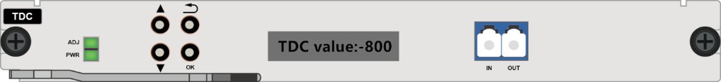
Product Features
- Adjustable: provides highly accurate, dynamically adjustable dispersion compensation over a wide range of dispersion values.
- Low Latency: TDC's latency is less than 25ns, making it ideal for time-sensitive networks.
- Multi-channel: TDC has full C-band coverage and can be used on 50GHz or 100GHz DWDM networks.
- Large dispersion compensation range, supporting ±1400ps/nm.
- Optical path is transparent and does not change the optical signal.
- Simple structure and easy maintenance.

Product Specification
Function | Note
Working wavelength range | C band: 1528nm~1568nm
Channel spacing | 50GHz or 100GHz optional
Dispersion compensation range | ±1400ps/nm
Absolute dispersion accuracy | ±25ps/nm（≤700ps/nm）; ±60ps/nm（≤1200ps/nm）
Introduction loss | ＜5.5dB
PDL | ＜0.2dB
PMD | ＜1ps
Max input optical power | +27dBm
Module warm-up time | ＜180s
Dispersion setting resolution | ±10ps/nm
Dispersion response time | ＜20s
Button and display function | Support local key operation dispersion compensation range setting, with the display can intuitively display the current status
Network management function | Support TDC dispersion compensation range remote setting and other functions
Occupied slot number | Support OTNS8600 series chassis，occupy 1slot
Optical interface | LC/UPC
Max power consumption | 10W
MTBF | ＞100000 hours

DCM: Dispersion Compensation Unit

The DCM (dispersion compensator modular) launched by Sintai Communication is a pure passive device. It can compensate the dispersion slope of standard single-mode optical fiber (G.652) in C-band. And it is used to repair the optical signal distorted by dispersion and compensate the damaged signal in optical transmission system, so as to improve the performance of the transmission system and achieve high-speed, large-capacity, long-distance communication. The dispersion range of the DCM can reach - 10 to - 2100ps/nm at 1550nm wavelength. And products with special requirements for central wavelength and dispersion can be also provided.

Product feature  - 100% Slope compensation of G.652 optical fiber in C-band  - Low insertion loss  - Low polarization mode dispersion  - Wide band Dispersion Compensation for DWDM System  - Packaging and interface types can be customized  - Comply with Telcordia GR-2854-CORE standard  - Conform to RoHS-6 (lead free)  Application scenario  - SDH high speed optical transmission system  - DWDM optical transmission system  - G.652 Standard single-mode optical fiber long-distance and metropolitan area communication system  Product specification  Item Parameter  Equivalent G.652 compensation length 20Km 40Km 60Km 80Km 100Km 120Km  1545nm wavelength dispersion (ps/nm) -340±20 -670±30 -1000±40 -1340±50 -1670±60 -2040±60  1545nm relative dispersion slope (nm⁻¹) 0.004±20%  Insertion loss (dB) ≤3.5 ≤5.0 ≤6.8 ≤8.7 ≤10.7 ≤12.9  Polarization mode dispersion (ps) ≤0.5 ≤0.8 ≤1.0 ≤1.2 ≤1.3 ≤1.4  Polarization dependent loss (ps) ≤0.1 ≤0.1 ≤0.1 ≤0.1 ≤0.1 ≤0.1  Optical reflection (dB) -27  Maximum permissible input power (dBm) +23  Working temperature range -5°C~70°C  Storage temperature range -40°C~85°C  Environmental/Reliability Testing Conform to Telcordia GR-2854 and GR1221standard  Interface type LC/PC or to be customized  Packaging Pluggable chassis: 1U, (D)220mm×(W)442mm×(H)44mm Rack mount: 1U, (D)220mm×(W)442mm×(H)44mm | 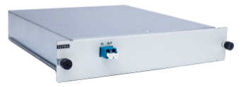  Pluggalbe Card Type
 | 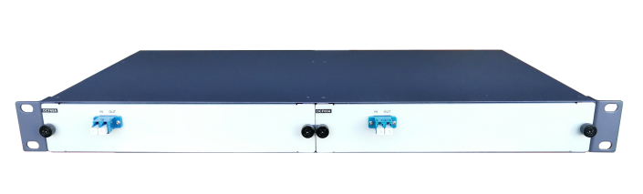1U Pluggalbe Rack Mout
 | 1U Integrated Rack Mount

OLP: Optical Protection Unit

The OLP optical protection card launched by Sintai Communication, main function is to assist the wavelength division system to complete optical layer protection solutions such as optical line 1+1 protection and optical wavelength 1+1 protection. It can monitor the primary and backup routing optical paths in real time. In the event that the fiber core is blocked or degraded in performance, it can implement the secure rearrangement automatically in the main and standby fiber core, so as to guarantee optical signals in the system line to recover quickly. OLP technology is to complete the routing switch operation in optical layer. The optical layer protection has the incomparable advantages over the protection of upper services, and it is the best solution to provide the user with an uninterrupted communication.

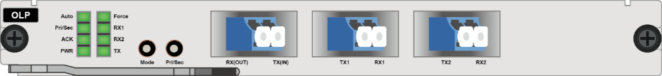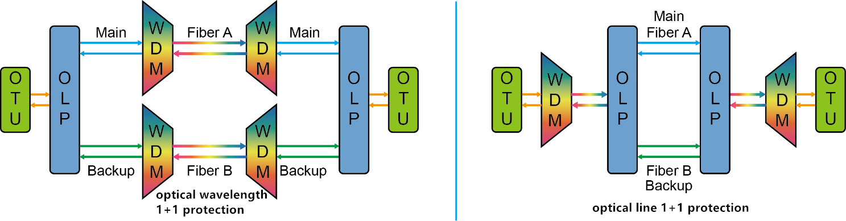

Product specification
Function |  | Description
Working wavelength range |  | 1260nm~1650nm
Switching mechanism |  | Selectively receipt from double transmission, and then single-ended rearrangement
Switching time |  | ＜20ms
Introduction loss | Tx port | ＜3.8dB
 | Rx port | ＜1.2dB
Monitoring of optical power range |  | -50 dBm ~+25dBm
Application scenes |  | - Optical line 1+1 protection  - Optical wavelength 1+1 protection
Network management function |  | supports the OLP optical power real-time monitoring, active switch scheduling, performance management, routing management, and other management functions
Occupied slot number |  | Support OTNS8600 series chassis, occupy 1 slot
Optical interface |  | LC/UPC
Max power consumption |  | 5W
MTBF |  | ＞100000 hours

MUX/DEMUX Unit: 8CH
MDU: 1~18 Wavelengths Multiplexing/Demultiplexing card

The MDU is multiplexing/demultiplexing card based on WDM technology launched by Sintai Communication is mainly used in CWDM or DWDM systems to complete the multiplexing and demultiplexing functions of 1~18 optical wavelengths. Different wavelengths of light can be multiplexed onto one fiber or multiple optical channels multiplexed in the same fiber can be separated by wavelength. Adopting advanced optical film filtering technology, it has a series of advantages such as low insertion loss, excellent channel consistency and high reliability. The number of channels can be customized according to customer requirements.

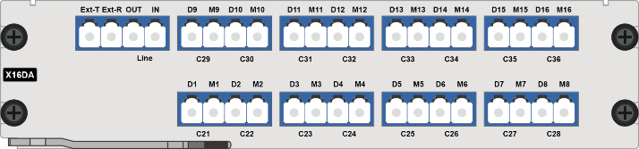
8 CH Mux/Demux 16 CH Mux/Demux

Product specification
Function | Description
Optical channel number | 2 | 4 | 8 | 16 | 18
Channel insertion loss | ≤1.2dB | ≤1.8dB | ≤2.6dB | ≤4.5dB | ≤5.0dB
Occupied slot number | Support OTNS8600 series chassis, occupy 1 slot |  |  | Support OTNS8600 series chassis, occupy 2 slots
Working wavelength range | - CWDM: 1271nm~1611nm  - DWDM: C Band（100GHz）
Channel center wavelength | ITU-T Grid
Line-side fiber number | Supports single-fiber or dual-fiber application on the line side.
Flatness | ≤0.5dB
Isolation ratio of adjacent channel | ≥30dB
Isolation ratio of non-adjacent channel | ≥45dB
Return loss | ≥50dB
Directivity | ≥55dB
Optical interface | LC/UPC
Max power consumption | 3W
MTBF | ＞100000 hours

MUX/DEMUX Unit: 16CH
MDU: 1~18 Wavelengths Multiplexing/Demultiplexing card

The MDU is multiplexing/demultiplexing card based on WDM technology launched by Sintai Communication is mainly used in CWDM or DWDM systems to complete the multiplexing and demultiplexing functions of 1~18 optical wavelengths. Different wavelengths of light can be multiplexed onto one fiber or multiple optical channels multiplexed in the same fiber can be separated by wavelength. Adopting advanced optical film filtering technology, it has a series of advantages such as low insertion loss, excellent channel consistency and high reliability. The number of channels can be customized according to customer requirements.

8 CH Mux/Demux 16 CH Mux/Demux

Product specification
Function | Description
Optical channel number | 2 | 4 | 8 | 16 | 18
Channel insertion loss | ≤1.2dB | ≤1.8dB | ≤2.6dB | ≤4.5dB | ≤5.0dB
Occupied slot number | Support OTNS8600 series chassis, occupy 1 slot |  |  | Support OTNS8600 series chassis, occupy 2 slots
Working wavelength range | - CWDM: 1271nm~1611nm  - DWDM: C Band（100GHz）
Channel center wavelength | ITU-T Grid
Line-side fiber number | Supports single-fiber or dual-fiber application on the line side.
Flatness | ≤0.5dB
Isolation ratio of adjacent channel | ≥30dB
Isolation ratio of non-adjacent channel | ≥45dB
Return loss | ≥50dB
Directivity | ≥55dB
Optical interface | LC/UPC
Max power consumption | 3W
MTBF | ＞100000 hours

40CH MUX/DEMUX Unit: AAWG
The AAWG (athermal arrayed waveguide grating) launched by Sintai Communication is based on waveguide grating technology on silicon substrates. It adopts unique thermal-free package design. It can achieve accurate channel coupling without power supply, software or temperature control. It has a series of advantages such as low insertion loss, high channel isolation and high stability. There are Gauss type and flat top type to be optional.

Product feature  - Low insertion loss (IL), high channel isolation  - High stability and reliability  - Provide 40/48/80/96 channels to be used  - Conform to ITU-T G.694.1, Telcordia GR-1209-CORE-2001 standard, Telcordia GR-1221-CORE-1999 standard, RoHS-6 (no lead)  Application area  - DWDM system  Product specification  Item AAWG DWDM MUX/DEMUX  Channel spacing 50GHz 100GHz  Channel type Flat top Gauss Flat top Gauss  Channel number 80/96 40/48  Wavelength accuracy (nm) ±0.05  -1dB bandwidth (nm) >0.34 >0.24 >0.38 >0.2  -3dB bandwidth (nm) >0.51 >0.3 >0.58 >0.4  Channel insertion loss (dB) <7.0 <6.0 <5.5 <3.5  Adjacent channel isolation (dB) >26 >23 >26  Non-adjacent channel isolation (dB) >30  Total isolation (dB) >20 >21  Flatness (dB) <1.5  Return loss (dB) >40  Directivity (dB) >50  Polarization-dependent loss (dB) <0.5  Polarization mode dispersion (ps) <0.5  Operating Temperature (°C) -10~+70  Storage Temperature (°C) -40 ~+85  Package type ABS box, 1U standard 19-inch rack | ABS box  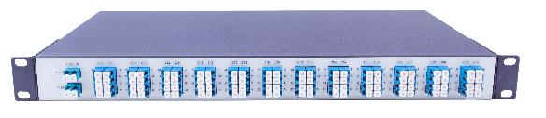  1U rack mount

48CH MUX/DEMUX Unit: AAWG
The AAWG (athermal arrayed waveguide grating) launched by Sintai Communication is based on waveguide grating technology on silicon substrates. It adopts unique thermal-free package design. It can achieve accurate channel coupling without power supply, software or temperature control. It has a series of advantages such as low insertion loss, high channel isolation and high stability. There are Gauss type and flat top type to be optional.

Product feature  - Low insertion loss (IL), high channel isolation  - High stability and reliability  - Provide 40/48/80/96 channels to be used  - Conform to ITU-T G.694.1, Telcordia GR-1209-CORE-2001 standard, Telcordia GR-1221-CORE-1999 standard, RoHS-6 (no lead)  Application area  - DWDM system  Product specification  Item AAWG DWDM MUX/DEMUX  Channel spacing 50GHz 100GHz  Channel type Flat top Gauss Flat top Gauss  Channel number 80/96 40/48  Wavelength accuracy (nm) ±0.05  -1dB bandwidth (nm) >0.34 >0.24 >0.38 >0.2  -3dB bandwidth (nm) >0.51 >0.3 >0.58 >0.4  Channel insertion loss (dB) <7.0 <6.0 <5.5 <3.5  Adjacent channel isolation (dB) >26 >23 >26  Non-adjacent channel isolation (dB) >30  Total isolation (dB) >20 >21  Flatness (dB) <1.5  Return loss (dB) >40  Directivity (dB) >50  Polarization-dependent loss (dB) <0.5  Polarization mode dispersion (ps) <0.5  Operating Temperature (°C) -10~+70  Storage Temperature (°C) -40 ~+85  Package type ABS box, 1U standard 19-inch rack | ABS box  1U rack mount

