HD 4/8HDMI H.264 ASI/IP Encoder
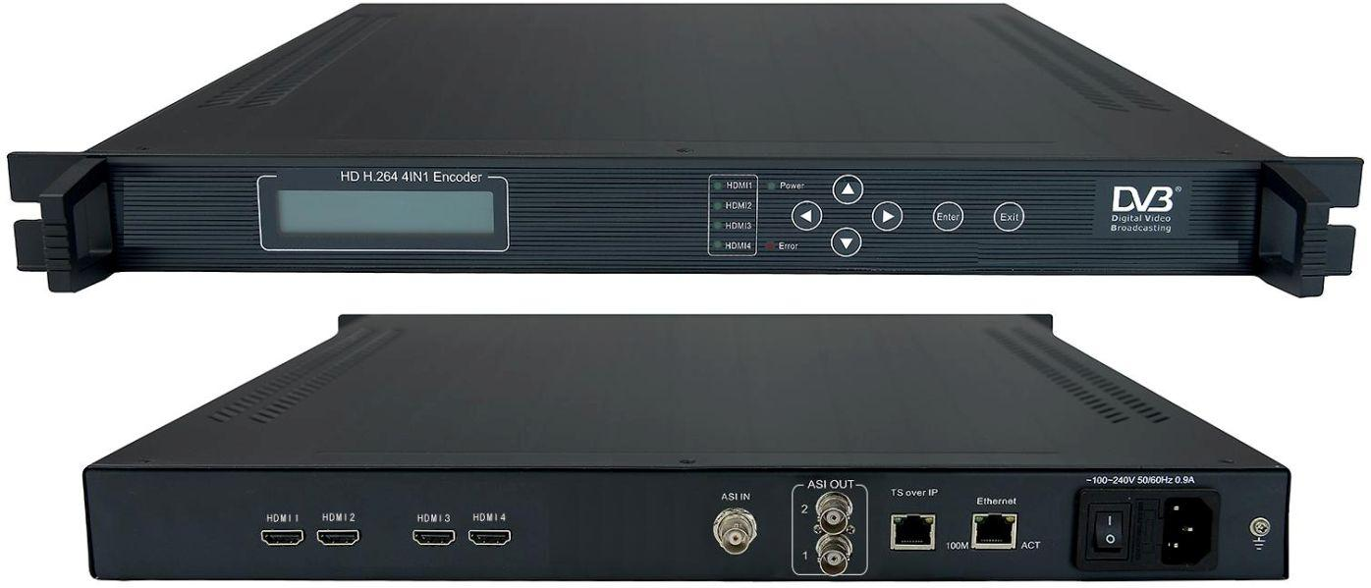
Model 1115 4HDMI
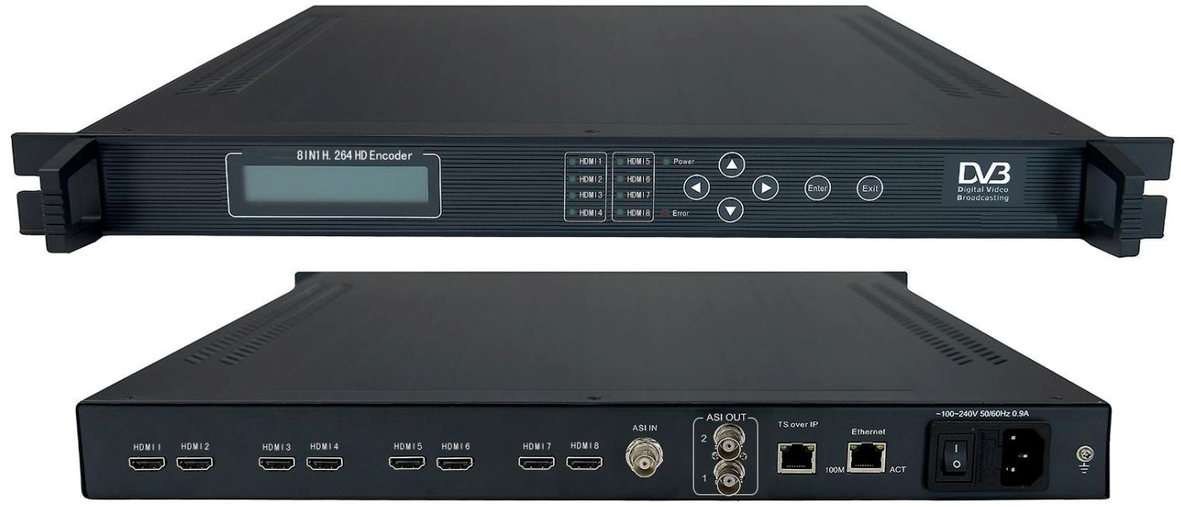
Model 1815 8HDMI
Overview
MPEG-4 AVC/H.264 HD IP Encoder supports 4/8*HDMI input, and generates DVB transport stream (TS/ASI) and SPTS/MPTS (TS over IP) output. It suits 1U rack and supports1080i/p, 720p and HDCP. Besides.
Technical Specification
Input | 4/8*HDMI interface, support HDCP
 | 1*ASI multiplex to MPTS out
Output | ASI | DVB standard, 2*BNC interface
 | IP | IP/UDP (TS over UDP), MPTS/SPTS,Unicast/Multicast
Video |  | 4:2:0 encoding H.264 HP@L4 MP@L3
HD:1920*1080*60/50i/p,1280*720*60p/50p;
SD:PAL(720*576i),NTSC(720*480i);
 |  | Bit rate :3 to 15Mbps (4:2:0) per channel, recommend 4-8 mbps,
 |  | CBR/VBR
Audio | Bitrate | 128, 160, 192, 224, 256, 320, 384Kbps
 | Volume | Volume range 0~31
 | Property | MPEG-1 Layer 2
 | Sampling | 48khz,etc.
Control | NMS (Ethernet Port), Keyboard + LCD
General Features | Size | 482mm*280mm *44mm,482mm*410mm*44mm
 | Temperature | 0~45°C (Operation); -20~80°C (Storage)
 | Power | 100-240VAC (±10%), 50Hz, 25W
Order Guide
1115 | HD H.264 4HDMI 1080p Encoder(4*HDMI+ASI in,ASI+IP(TS UDP) out)
1815 | HD H.264 8HDMI 1080p Encoder(8HDMI+ASI in,ASI+IP(TS UDP) out)
1866 | HD H.264 8HDMI 1080p Encoder(8HDMI in,only IP(TS UDP) out)

